What is HTML ?

HTML stands for Hyper Text Markup Language.

The First Version of HTML was introduced in 1991.

HTML is the standard markup language used to create web pages.

Markup language contains set of markup tags.

Markup tags tells the web browser how to display content for the user in different format.

Note:

Along with CSS and Javascript , HTML creates more interactive and stylish web pages.

Web Browser : Web Browser is software used to open web applications from webserver.

Ex: Google chrome , firefox , opera , etc.

Types of Websites:

Generally websites are divided into following 2 types.

1. Static website.
2. Dynamic website.

Static Website are implemented only by client side scripting like HTML,CSS, JavaScript, etc.

Dynamic Websites are the combination of client side and server side scripting like

HTML,CSS, JavaScript, ( PHP / ASP / JSP / .... ) etc.

Types of Scripts :

Scripts are divided into following 2 types.

1. Client side script :

A script which executes in the web browser.

Eg. HTML , CSS , JavaScript , Jquery , BootStrap , .. etc

1. Server Side Script :

The Script which executes in webserver.

Eg. PHP , ASP , JSP ,.... etc

Introduction to World Wide Web ( W3C)

It Stands for( World wide Web Consortium) which is an international consortium of companies. It was founded in 1994 by Tim Berners Lee.

W3C Activities:

1. W3C creates and maintains WWW standards.
2. W3C is working to standardize the web.
3. W3C is organized is a number organization .

W3C Numbers: There are the following well known nos. In W3C.

1. IBM
2. Microsoft
3. America online
4. Apple
5. Adobe
6. Macromedia
7. Sun micro systems, ..... etc

Versions of HTML

As per W3C recommendation the following versions are released into market.

1. HTML 1.O in the year 1991.
2. HTML 2.0 in the year 1994
3. HTML 3.0 in the year 1997
4. HTML 4.0 in the year 1998
5. XHTML in the year 2001
6. HTML 5.0 in the year 2008

What is an HTML Element?

An HTML element is defined by a start tag, some content, and an end tag:

<tagname>Content goes here...</tagname>

The HTML element is everything from the start tag to the end tag:

<h1> About HTML </h1>

<p> HTML is easy to learn.</p>

Simple html program

<!DOCTYPE html>  
<html>  
<head>  
<title> learning html </title>  
</head>  
<body>  
<h1> About HTML </h1>  
<p> HTML is easy to learn.</p>  
</body>  
</html>

Explanation:

* The <!DOCTYPE html> declaration defines that this document is an HTML5 document
* The <html> element is the root element of an HTML page
* The <head> element contains meta information about the HTML page
* The <title> element specifies a title for the HTML page (which is shown in the browser's title bar or in the page's tab)
* The <body> element defines the document's body, and is a container for all the visible contents, such as headings, paragraphs, images, hyperlinks, tables, lists, etc.
* The <h1> element defines a large heading
* The <p> element defines a paragraph

## Saving the HTML Page

While saving give an valid file name followed by extension ( .html or .htm )

And set the encoding to **UTF-8** (which is the preferred encoding for HTML files).

Ex: home.html

Index .html

Gallery.htm

Aboutus.htm

Output:

For output open the file in your favorite browser.

The output for the above program will be.

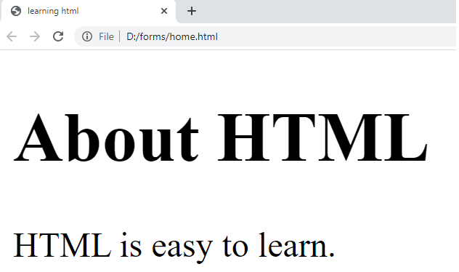

### View HTML Source Code:

Right-click in an HTML page and select "View Page Source" (in Chrome) or "View Source" (in Edge), or similar in other browsers. This will open a window containing the HTML source code of the page.

### Inspect an HTML Element:

Right-click on an element (or a blank area), and choose "Inspect" or "Inspect Element" to see what elements are made up of (you will see both the HTML and the CSS).

HTML Headings

HTML headings are defined with the <h1> to <h6> tags.

<h1> defines the most important heading. <h6> defines the least important heading.

Ex:

<!DOCTYPE html>

<html>

<body>

<h1>Heading 1</h1>

<h2>Heading 2</h2>

<h3>Heading 3</h3>

<h4>Heading 4</h4>

<h5>Heading 5</h5>

<h6>Heading 6</h6>

</body>

</html>

output:

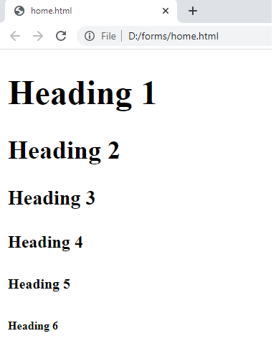

Headings Are Important

Search engines use the headings to index the structure and content of your web pages.

Users often skim a page by its headings. It is important to use headings to show the document structure.

<h1> headings should be used for main headings, followed by <h2> headings, then the less important <h3>, and so on.

**Note:** Use HTML headings for headings only. Don't use headings to make text **BIG** or **bold**.

# HTML Paragraphs

Paragraph element is used to publish text on the web pages.

Paragraphs are defined with the <p> tag. Paragraph tag is a very basic and typically the first tag you will need to publish your text on the web pages

Ex:

<!DOCTYPE html>

<html>

<body>

<p>This is a paragraph.</p>

<p>This is a paragraph.</p>

<p>This is a paragraph.</p>

</body>

</html>

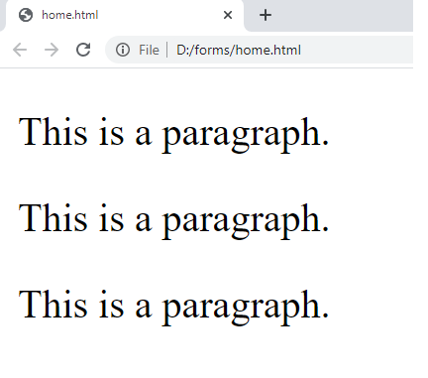

**Creating Line Breaks**

The <br> tag is used to insert a line break on the web page.

Since the <br> is an [empty element](https://www.tutorialrepublic.com/html-tutorial/html-elements.php#empty-elements), so there is no need of corresponding </br> tag.

Ex:

<!DOCTYPE html>

<html >

<head>

<title>Inserting Line Breaks in HTML</title>

</head>

<body>

<p>This is a paragraph <br> with line break.</p>

<p>This is <br>another paragraph <br> with line breaks.</p>

</body>

</html>

o/p

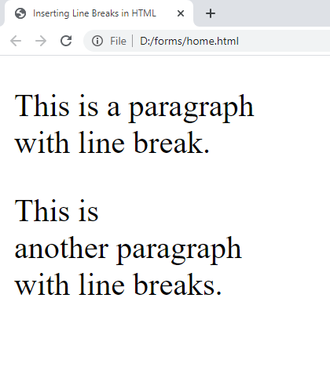

**Creating Horizontal Rules**

You can use the <hr> tag to create horizontal rules or lines to visually separate content sections on a web page. Like <br>, the <hr> tag is also an empty element. Here's an example:

Ex:

<!DOCTYPE html>

<html>

<body>

<h1>The Main Languages of the Web</h1>

<p>HTML is the standard markup language for creating Web pages. HTML describes the structure of a Web page, and consists of a series of elements. HTML elements tell the browser how to display the content.</p>

<hr>

<p>CSS is a language that describes how HTML elements are to be displayed on screen, paper, or in other media. CSS saves a lot of work, because it can control the layout of multiple web pages all at once.</p>

<hr>

<p>JavaScript is the programming language of HTML and the Web. JavaScript can change HTML content and attribute values. JavaScript can change CSS. JavaScript can hide and show HTML elements, and more.</p>

</body>

</html>

o/p:

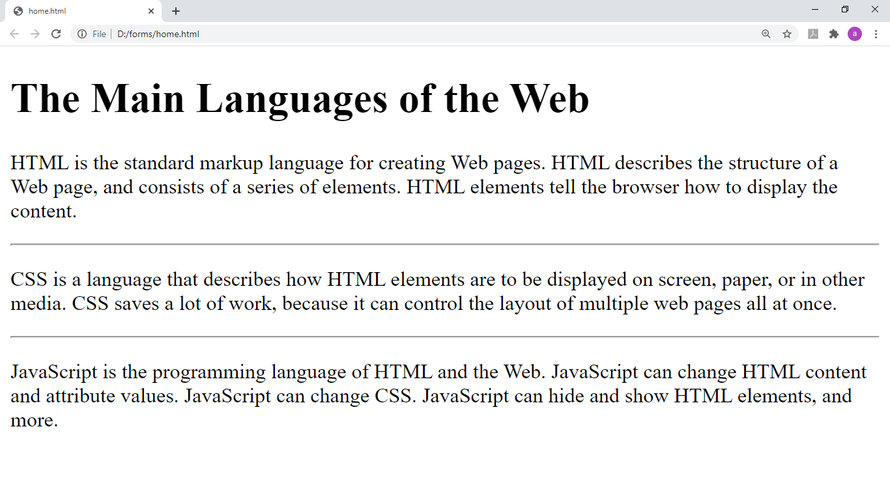

**Managing White Spaces**

Normally the browser will display the multiple spaces created inside the HTML code by pressing the *space-bar key* or *tab key* on the keyboard as a single space. Multiple line breaks created inside the HTML code through pressing the enter key is also displayed as a single space.

The following paragraphs will be displayed in a single line without any extra space:

Ex:

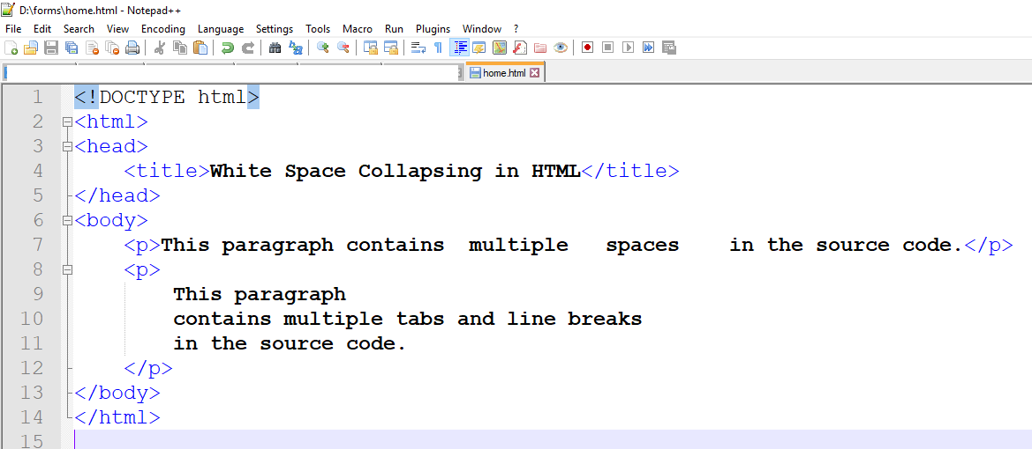

o/p:

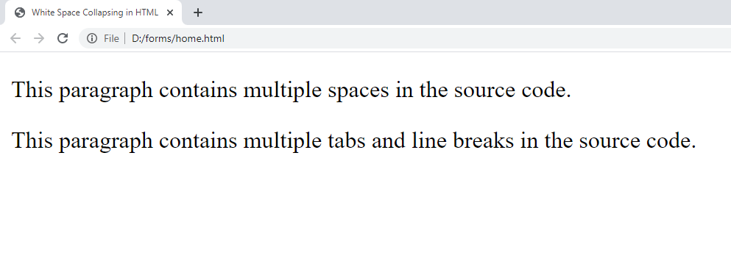

Insert &nbsp; for creating extra consecutive spaces, while insert <br> tag for creating line breaks on your web pages, as demonstrated in the following example:

Ex:

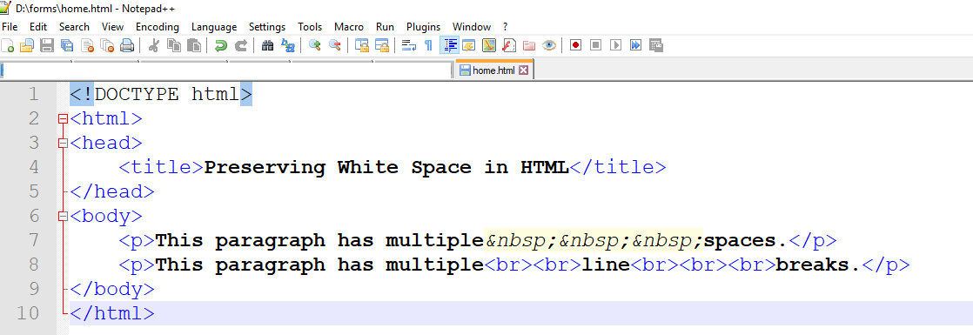

o/p:

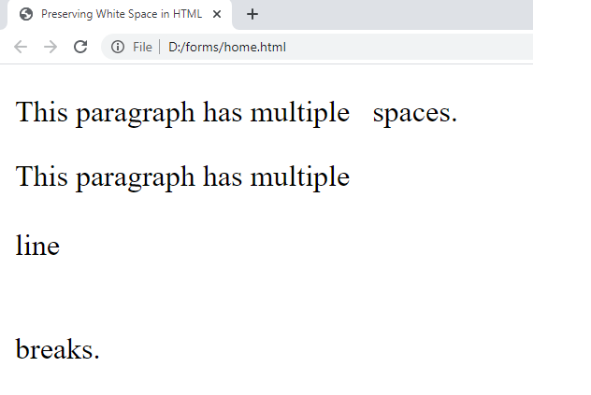

**Defining Preformatted Text**

Sometimes, using &nbsp;, <br>, etc. for managing spaces isn't very convenient. Alternatively, you can use the <pre> tag to display spaces, tabs, line breaks, etc. exactly as written in the HTML file. It is very helpful in presenting text where spaces and line breaks are important like poem or code.

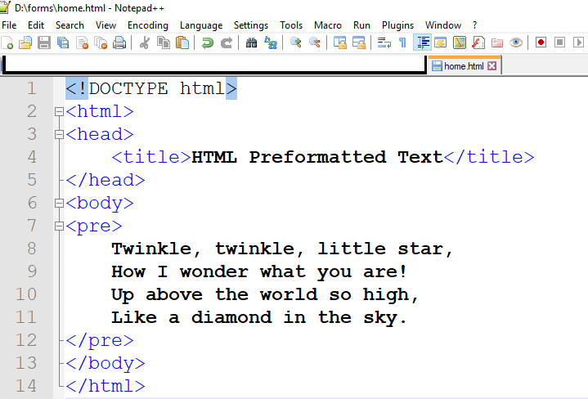

o/p:

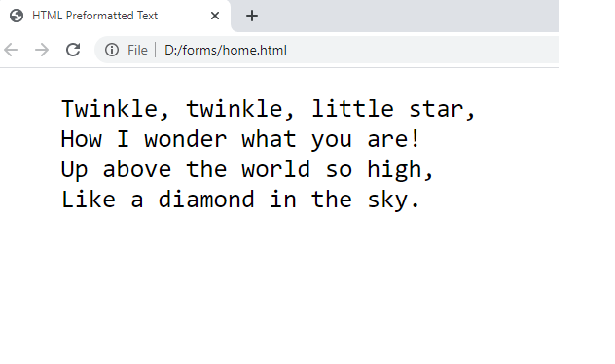

# HTML Comments

HTML comments are not displayed in the browser, but they can help document your HTML source code.

you can add comments to your HTML source by using the following syntax:

<!-- Write your comments here -->

Comments are also great for debugging HTML, because you can comment out HTML lines of code, one at a time, to search for errors:

Ex: ( multi line comment)

<!-- Do not display this image at the moment  
 <img border="0" src="pic_trulli.jpg" alt="Trulli">  
-->

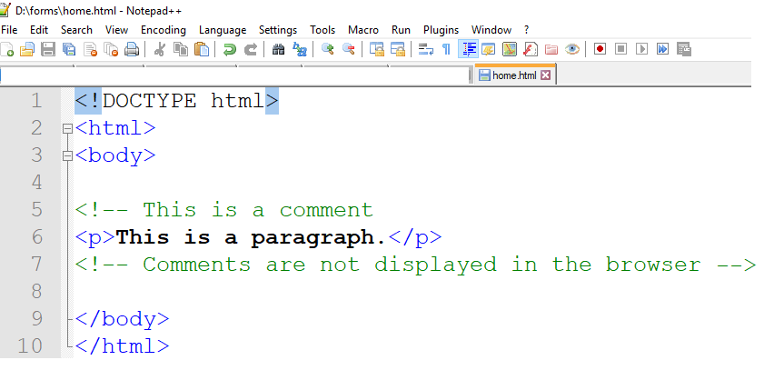

Output:

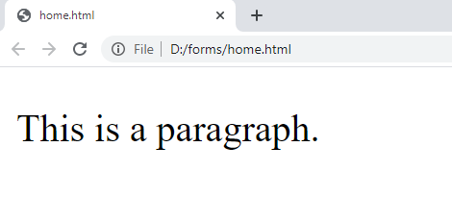

# Text Formatting

<b> or <strong>

The elements <b> and <strong> are used to make the text bold. When you want to make text bold using <strong> rather than <b>.

Ex:

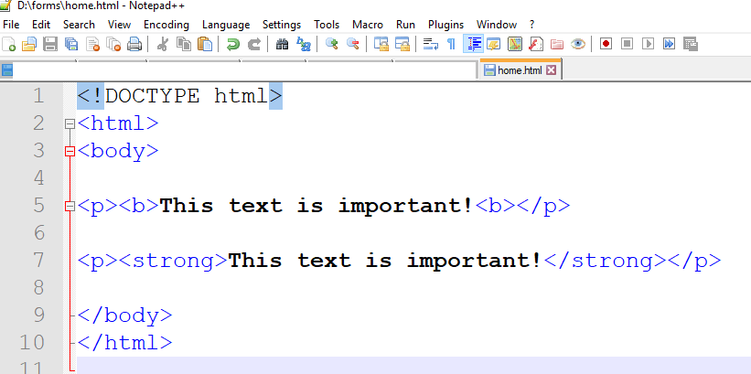

Output:

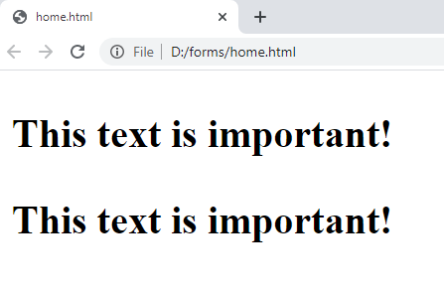

<i> and <em>

The <i> and <em> elements are used to make the text italic. When you want to make text italic use <em> rather than <i>.

Ex:

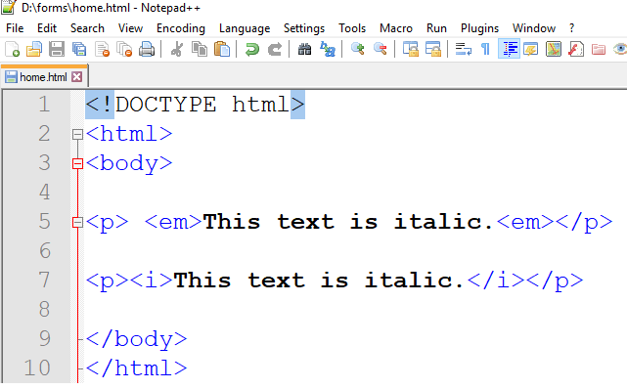

Output:

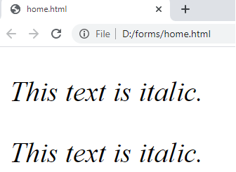

<mark> Element

The HTML <mark> element defines text that should be marked or highlighted:

Ex:

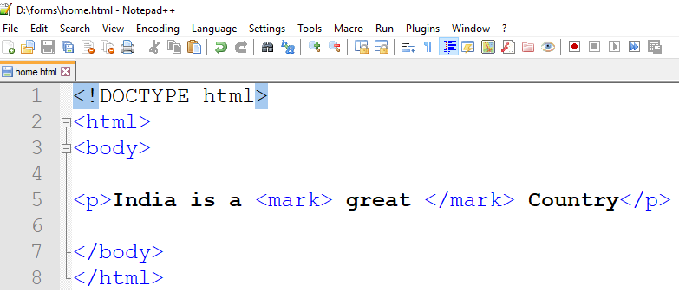

Output:

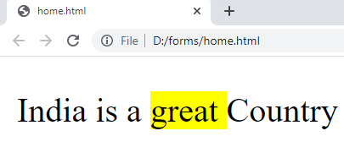

<del> Element

The HTML <del> element defines text that has been deleted from a document. Browsers will usually strike a line through deleted text:

Ex:

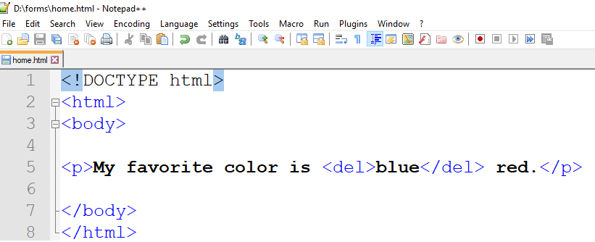

Output:

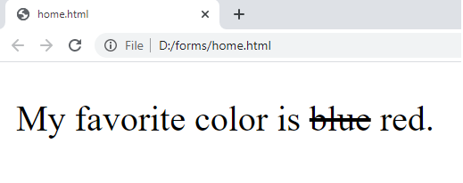

<sub> Element & <sup> Element:

The HTML <sub> element defines subscript text. Subscript text appears half a character below the normal line, and is sometimes rendered in a smaller font. Subscript text can be used for chemical formulas, like H2O

The HTML <sup> element defines superscript text. Superscript text appears half a character above the normal line, and is sometimes rendered in a smaller font.

Ex:

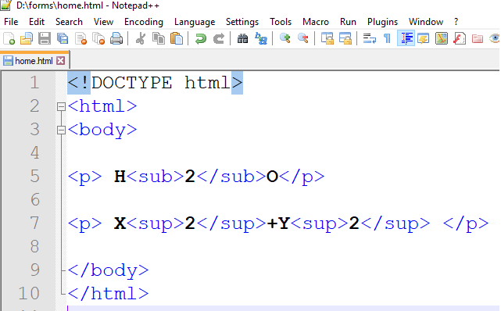

Output:

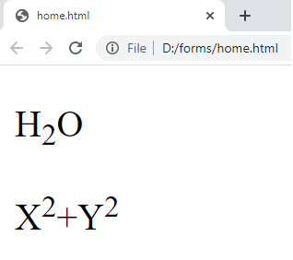

Attributes:

HTML attributes provide additional information about HTML elements.

* All HTML elements can have **attributes**
* Attributes provide **additional information** about elements
* Attributes are always specified in **the start tag**
* Attributes usually come in name/value pairs like: **name="value"**

Ex: href , src , width , height , alt , style , lang , title , … etc

The title Attribute

The title attribute defines some extra information about an element.

The value of the title attribute will be displayed as a tooltip when you mouse over the element: 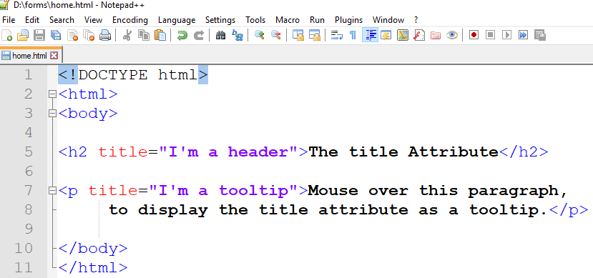

Output: 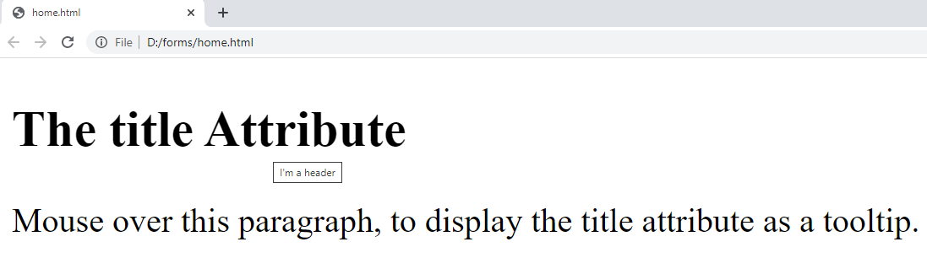

# lang Attribute

* Always use a language attribute on the html tag to declare the default language of the text in the page.
* When a page contains content in another language , add a language attribute to an element surrounding that content.
* The default language is en-US (American English)
* For Indian English use ( en-IN)
* It will be very useful in SEO.

Common examples are "en" for English, "es" for Spanish, "fr" for French, “or” for odia , “hi” for hindi and so on.

Ex1:

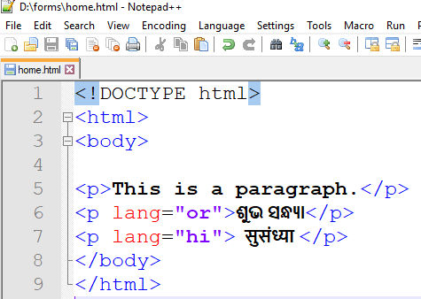

Output:

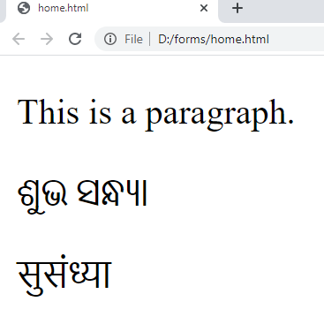

Ex:2

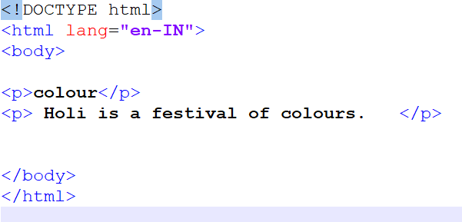

Output:

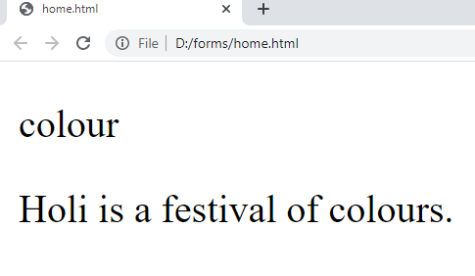

In the above example the lang attribute is used by SEO and the browser. The browser will know the text is in which language. ( As we know English language also differs like American English , britan English)

Style Attribute

The HTML style attribute is used to add styles to an element, such as color, font, size, and more.

The HTML style attribute has the following syntax:

<tagname style="property:value;">

The ***property*** is a CSS property. The ***value*** is a CSS value.

Background Color

The CSS background-color property defines the background color for an HTML element.

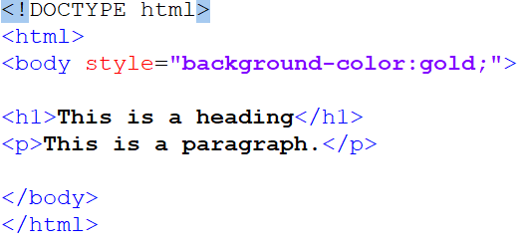

Output:

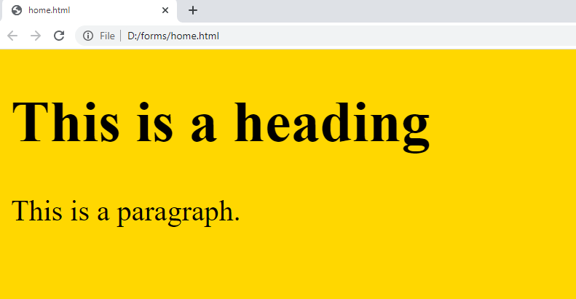

Text Color

The CSS color property defines the text color for an HTML element:

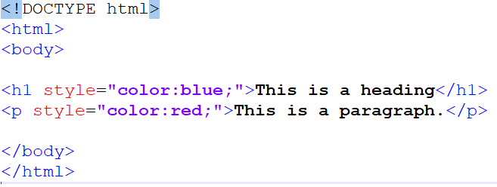

Output:

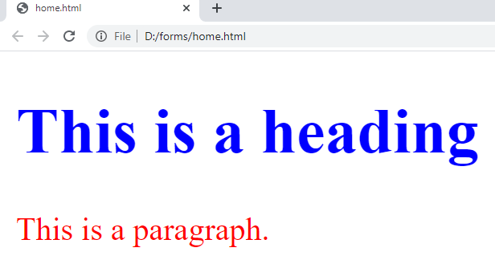

The CSS font-family property defines the font to be used for an HTML element.

The CSS font-size property defines the text size for an HTML element.

The CSS text-align property defines the horizontal text alignment for an HTML element

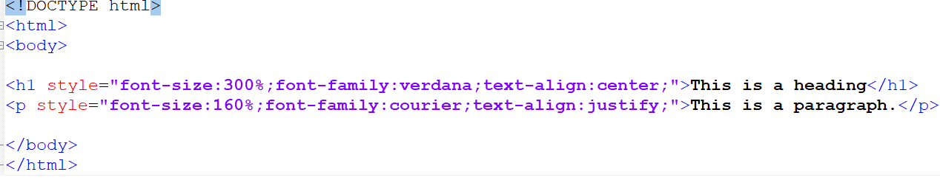

Output:

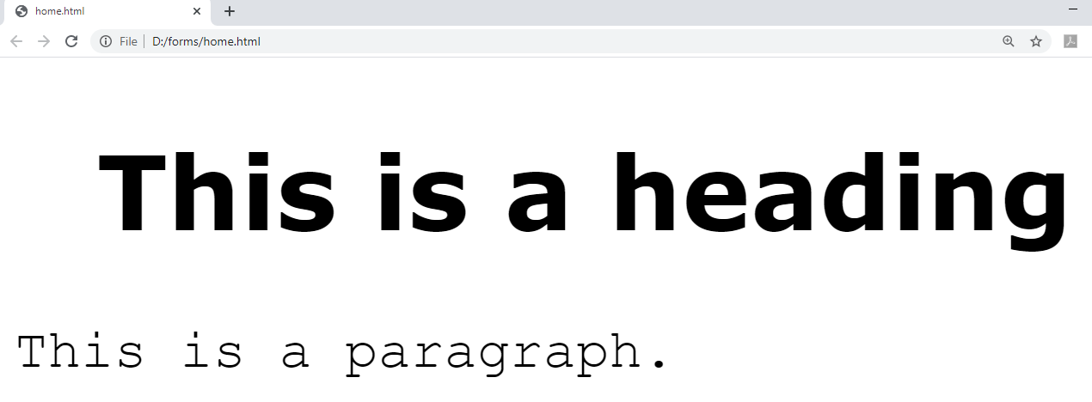

HTML <abbr> for Abbreviations

The HTML <abbr> tag defines an abbreviation or an acronym, like "HTML", "CSS", "Mr.", "Dr.", "ASAP", "ATM".

Marking abbreviations can give useful information to browsers, translation systems and search-engines.

**Tip:** Use the global title attribute to show the description for the abbreviation/acronym when you mouse over the element.

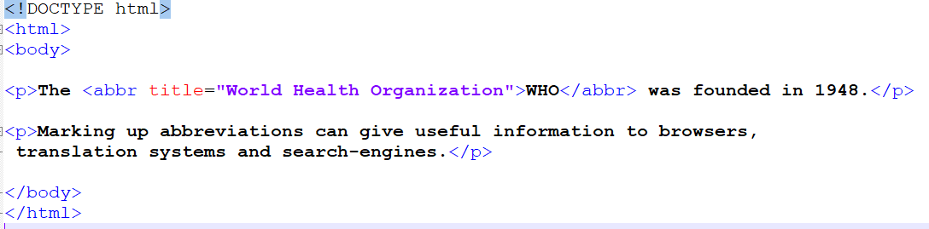

Output:

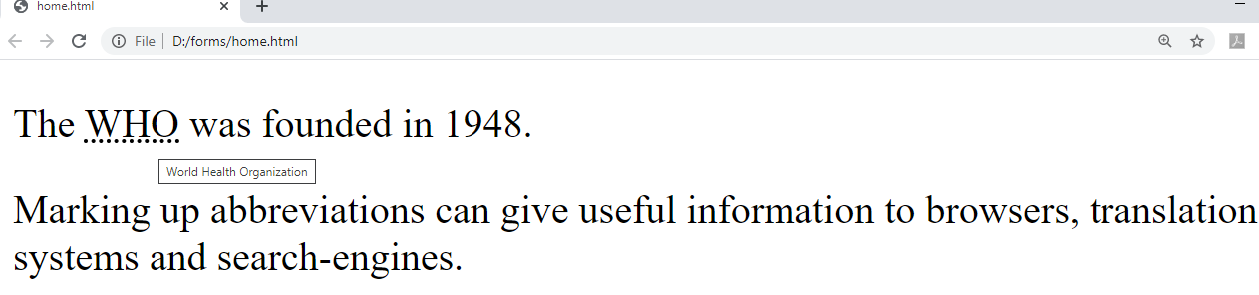

HTML <address> for Contact Information

The HTML <address> tag defines the contact information for the author/owner of a document or an article.

The contact information can be an email address, URL, physical address, phone number, social media handle, etc.

The text in the <address> element usually renders in *italic,* and browsers will always add a line break before and after the <address> element.

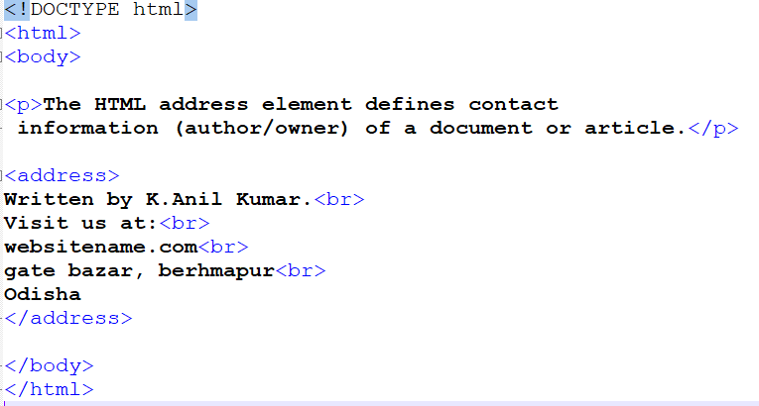

Output:

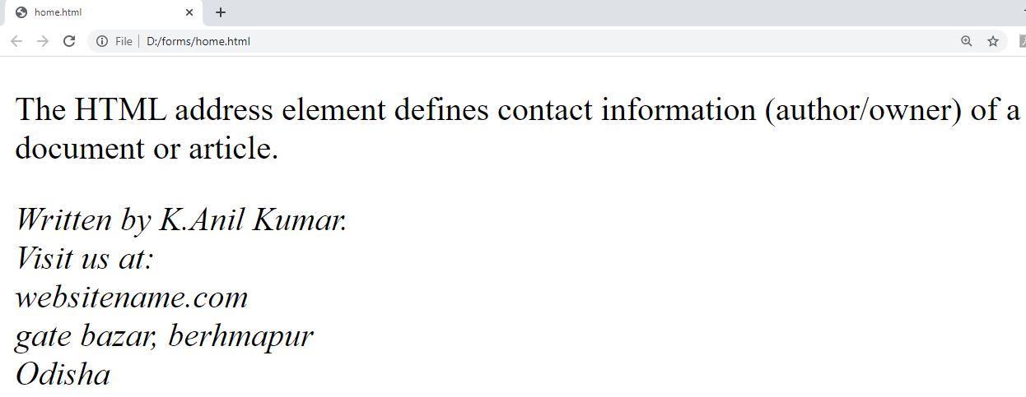

Color Values

In HTML, colors can also be specified using RGB values, HEX values, HSL values, RGBA values, and HSLA values.

( search in any search engine for color picker. Choose your favorite color, copy the rgb / hex values.

Try to use hex values rather than color names. As html supports 140 standar color names. As hex/ rbg supports ( 256 * 256 * 256) color options. Choice is yours.

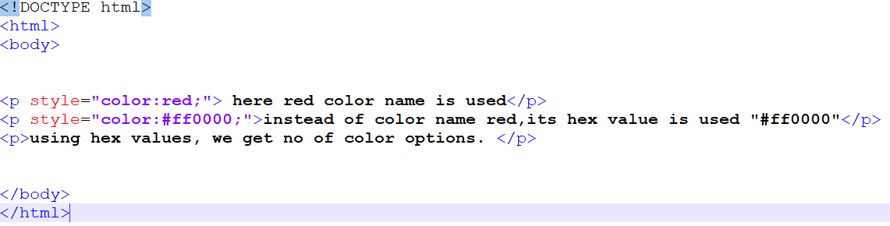

Output:

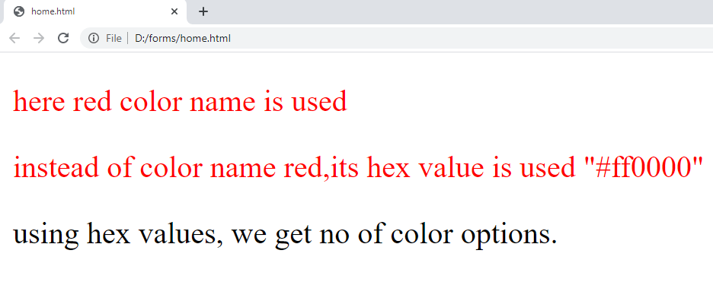

Hyperlinks:

A webpage can contain various links that take you directly to other pages. These links are known as hyperlinks.

Hyperlinks allow visitors to navigate between Web sites by clicking on words, phrases, and images. Thus you can create hyperlinks using text or images available on a webpage.

Linking Documents

A link is specified using HTML tag <a>. This tag is called **anchor tag** and anything between the opening <a> tag and the closing </a> tag becomes part of the link and a user can click that part to reach to the linked document. Following is the simple syntax to use <a> tag.

<a href="*url*">*link text*</a>

Ex:

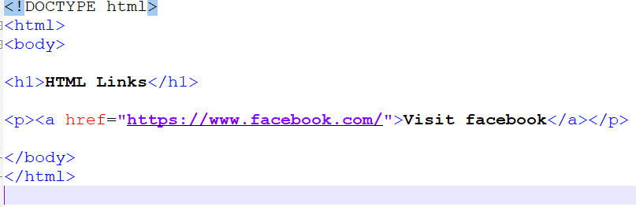

Output:

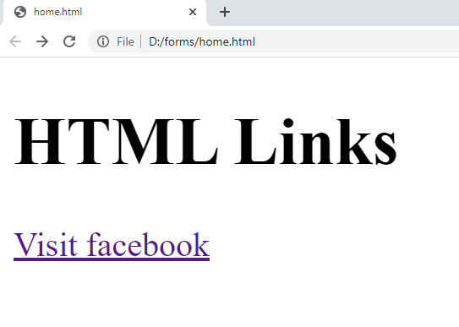

HTML Links - The target Attribute

By default, the linked page will be displayed in the current browser window. To change this, you must specify another target for the link.

The target attribute specifies where to open the linked document.

The target attribute can have one of the following values:

* _self - Default. Opens the document in the same window/tab as it was clicked

<p><a href=”<https://www.facebook.com/>” target=”_self”>Visit facebook</a></p>

* _blank - Opens the document in a new window or tab

<p><a href=”<https://www.facebook.com/> “ target=”_blank”>Visit facebook</a></p>

* _parent - Opens the document in the parent frame
* _top - Opens the document in the full body of the window

Use an Image as a Link

To use an image as a link, just put the <img> tag inside the <a> tag:

Ex:

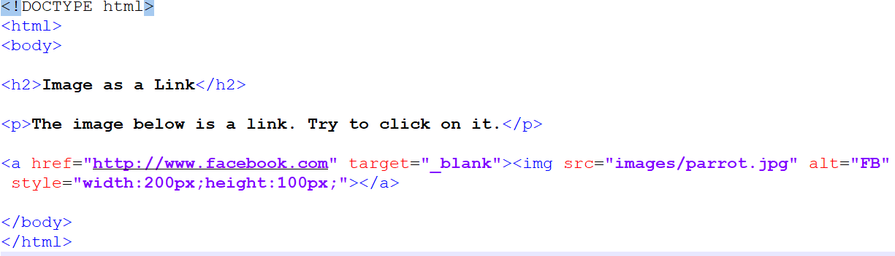

Output:

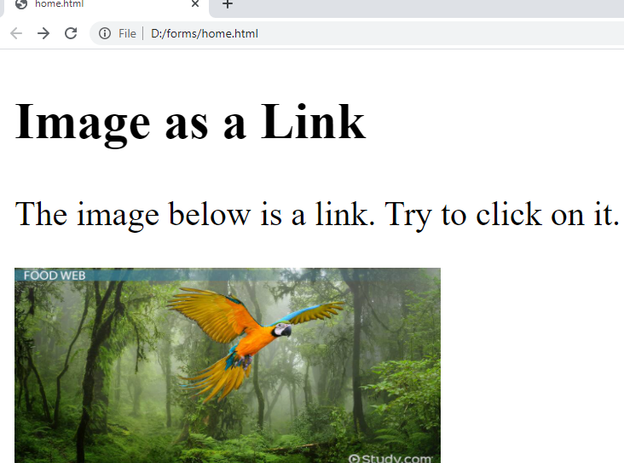

## Section link or Linking to a Page Section

## You can create a link to a particular section of a given webpage

## Ex:

<!DOCTYPE html>

<html>

<head>

<title> Section link </title>

<style>

p{

font-size:35px;

}

</style>

</head>

<body>

<p> <a href="#hw5"> go to content 5</a> </p>

<p id="hw1"> hello world 1 </p> <br><br>

<p> hello world 2 </p> <br><br>

<p> hello world 3 </p> <br><br>

<p> hello world 4 </p> <br><br>

<p id="hw5"> hello world 5 </p> <br><br>

<p> hello world 6 </p> <br><br>

<p> hello world 7 </p> <br><br>

<p> hello world 8 </p> <br><br>

<p> hello world 9 </p> <br><br> >

<p> <a href="#hw1"> Go to content 1</a> </p>

</body>

</html>

Output:

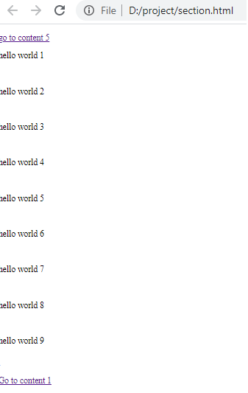

# HTML Images

Images are very important to beautify as well as to depict many complex concepts in simple way on your web page.

Images Syntax

The HTML <img> tag is used to embed an image in a web page.

Images are not technically inserted into a web page; images are linked to web pages. The <img> tag creates a holding space for the referenced image.

The <img> tag is empty, it contains attributes only, and does not have a closing tag.

The <img> tag has two required attributes:

* src - Specifies the path to the image
* alt - Specifies an alternate text for the image

<img src="*url*" alt="alternatetext">

The src Attribute

The required src attribute specifies the path (URL) to the image.

**Note:** When a web page loads; it is the browser, at that moment, that gets the image from a web server and inserts it into the page. Therefore, make sure that the image actually stays in the same spot in relation to the web page, otherwise your visitors will get a broken link icon. The broken link icon and the alt text are shown if the browser cannot find the image.

The alt Attribute

The required alt attribute provides an alternate text for an image, if the user for some reason cannot view it (because of slow connection, an error in the src attribute, or if the user uses a screen reader).

The value of the alt attribute should describe the image:

Ex:

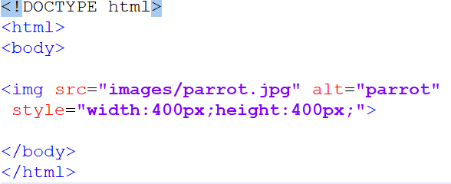

Output:

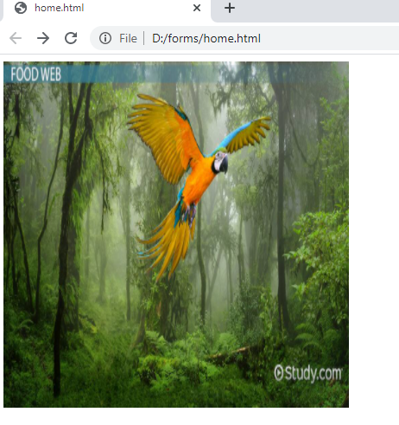

**Note:** Always specify the width and height of an image. If width and height are not specified, the web page might flicker while the image loads.

<img src="images/parrot.jpg" alt="parrot"

Width=”400” height=”400">

<img src="images/parrot.jpg" alt="parrot"

style="width:400px;height:400px;">

Width and Height, or Style?

The width, height, and style attributes are all valid in HTML.

However, we suggest using the style attribute. It prevents styles sheets from changing the size of images:

--------------------------------------------------------------------------------------------------------

Table Tag

HTML tables allow web developers to arrange data into rows and columns.

The <table> tag defines an HTML table.

Each table row is defined with a <tr> tag. Each table header is defined with a <th> tag. Each table data/cell is defined with a <td> tag.

By default, the text in <th> elements are bold and centered.

By default, the text in <td> elements are regular and left-aligned.

**Note:** The <td> elements are the data containers of the table.  
They can contain all sorts of HTML elements; text, images, lists, other tables, etc.

HTML Table - Add a Border

To add a border to a table, use the CSS border property:

table, th, td {  
  border: 1px solid black;  
}

HTML Table - Collapsed Borders

To let the borders collapse into one border, add the CSS border-collapse property

table, th, td {  
  border: 1px solid black;  
  border-collapse: collapse;  
}

HTML Table - Add Cell Padding

Cell padding specifies the space between the cell content and its borders.

If you do not specify a padding, the table cells will be displayed without padding.

To set the padding, use the CSS padding property:

th, td {  
  padding: 15px;  
}

HTML Table - Add Border Spacing

Border spacing specifies the space between the cells.

To set the border spacing for a table, use the CSS border-spacing property:

table {  
  border-spacing: 5px;  
}

HTML Table - Left-align Headings

By default, table headings are bold and centered.

To left-align the table headings, use the CSS text-align property:

th {  
  text-align: left;  
}

Ex:

<!doctype html>

<html>

<head>

<title> Tables concept </title>

<style>

table,th,td{

border:1px solid black;

border-collapse:collapse;

}

tr{

text-align:center;

}

th,td{

padding:15px;

}

thead{

color:red;

}

</style>

</head>

<body>

<table style="width:50%">

<caption> Student Details </caption>

<thead>

<tr>

<th> rollno</th>

<th>name </th>

<th>age </th>

<th> gender </th>

<th> Picture</th>

<th> profile </th>

</tr>

</thead>

<tbody>

<tr>

<td> 1 </td>

<td> jack </td>

<td> 23 </td>

<td> M </td>

<td> <img src="images/download.jpg" height="100" width="100"> </td>

<td> <a href="india.html" target="_blank"> View Profile</a> </td>

</tr>

<tr>

<td> 2 </td>

<td> smith </td>

<td> 41 </td>

<td> M </td>

<td> <img src="images/pic2.jpg" height="100" width="100"> </td>

<td> </td>

</tr>

<tr>

<td> 3 </td>

<td> rose </td>

<td> 21 </td>

<td> F </td>

<td> <img src="images/rkojavqo0o.jpg" height="100" width="100"> </td>

<td> </td>

</tr>

</tbody>

</table>

</body>

</html>

Output:

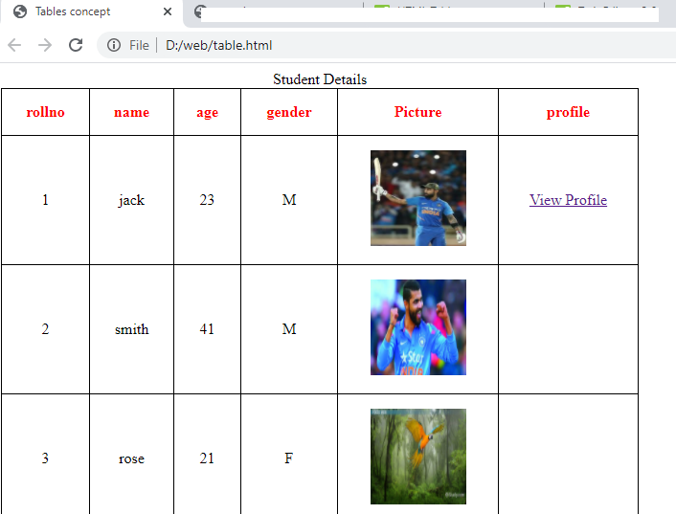

Colspan & rowspan:

To make a cell span more than one column, use the colspan attribute

To make a cell span more than one row, use the rowspan attribute

Ex:

<!DOCTYPE html>

<html>

<head>

<title> margins </title>

<style>

td{

text-align:center;

}

</style>

</head>

<body>

<table border="1" cellspacing="0" height="400" width="500">

<tr>

<td colspan="5"> Room Tariff</td>

</tr>

<tr>

<td rowspan="3"> Room Type</td>

<td colspan=2"> Deluxe </td>

<td colspan="2">Executive </td>

</tr>

<tr>

<td>0 </td>

<td> 0</td>

<td>0 </td>

<td>0 </td>

</tr>

<tr>

<td>0 </td>

<td> 0</td>

<td>0 </td>

<td>0 </td>

</tr>

</table>

<br/><br/><br/>

<table border="1" cellspacing="0" height="400" width="500">

<tr>

<td colspan="4"> a</td>

</tr>

<tr>

<td rowspan="2"> b</td>

<td> b</td>

<td> b</td>

<td rowspan="2"> b</td>

</tr>

<tr>

<td> c</td>

<td> c</td>

</tr>

<tr>

<td colspan="4"> d</td>

</tr>

</table>

</body>

</html>

Output:

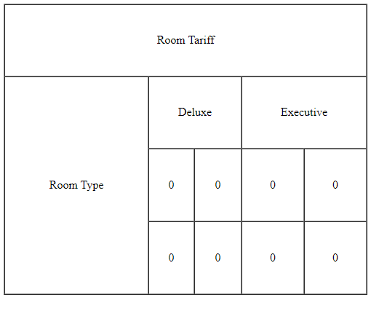

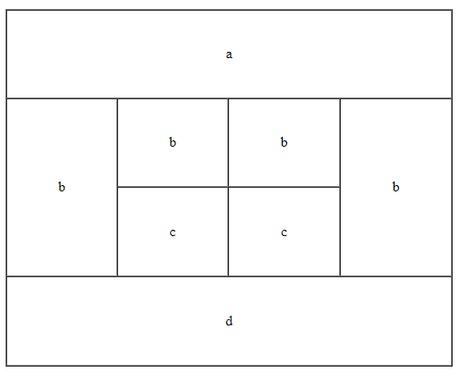

Ex: school time table.

<!DOCTYPE html>

<html>

<head>

<title> colspan rowspan </title>

<style>

table{

height:400px;

width:50%;

}

table,th,td{

border:1px solid black;

border-collapse:collapse;

}

tr{

text-align:center;

}

.xyz{

background-color:yellow;

}

#l1{

background-color:violet;

}

</style>

</head>

<body>

<table>

<thead>

<tr>

<th colspan="6"> Time Table </th>

</tr>

</thead>

<tbody>

<tr>

<td rowspan="6"> Hours </td>

<td class="xyz"> Mon </td>

<td class="xyz"> Tue </td>

<td class="xyz"> Wed </td>

<td class="xyz"> Thu </td>

<td class="xyz"> Fri </td>

</tr>

<tr>

<td>science </td>

<td> Maths </td>

<td> science </td>

<td> Maths </td>

<td> Arts </td>

</tr>

<tr>

<td>science </td>

<td> Maths </td>

<td> science </td>

<td> Maths </td>

<td> Arts </td>

</tr>

<tr>

<td colspan="5" id="l1"> Lunch </td>

</tr>

<tr>

<td>science </td>

<td> Maths </td>

<td> science </td>

<td> Maths </td>

<td rowspan="2"> Project </td>

</tr>

<tr>

<td>science </td>

<td> Maths </td>

<td> science </td>

<td> Maths </td>

</tr>

</tbody>

</table>

</body>

</html>

Output:

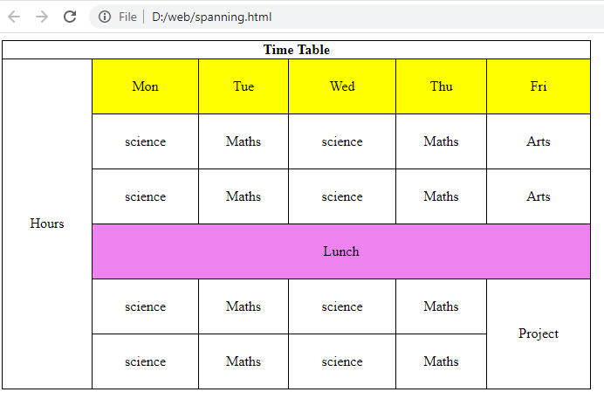

# HTML Lists

HTML lists allow web developers to group a set of related items in lists

* **<ul>** − An unordered list. This will list items using plain bullets.
* **<ol>** − An ordered list. This will use different schemes of numbers to list your items.
* **<dl>** − A definition list. This arranges your items in the same way as they are arranged in a dictionary.

Unordered HTML List

An unordered list starts with the <ul> tag. Each list item starts with the <li> tag.

The list items will be marked with bullets (small black circles) by default.

Ex:

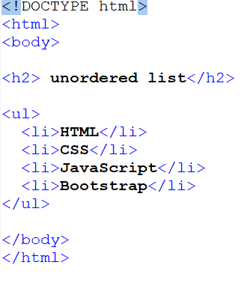

Output:

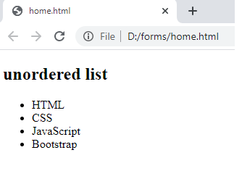

Unordered HTML List - Choose List Item Marker

The CSS list-style-type property is used to define the style of the list item marker. It can have one of the following values:

disc , circle , square , none , etc.

style="list-style-type:square;"

ex:

<!DOCTYPE html>

<html>

<body>

<h2> unordered list</h2>

<ul style="list-style-type:square;">

<li>HTML</li>

<li>CSS</li>

<li>JavaScript</li>

<li>Bootstrap</li>

</ul>

</body>

</html>

Output:

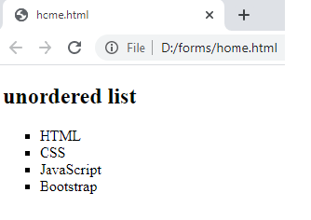

# Ordered Lists

The HTML <ol> tag defines an ordered list. An ordered list can be numerical or alphabetical.

An ordered list starts with the <ol> tag. Each list item starts with the <li> tag.

The list items will be marked with numbers by default.

Ex:

<!DOCTYPE html>

<html>

<body>

<h2> ordered list</h2>

<ol>

<li>HTML</li>

<li>CSS</li>

<li>JavaScript</li>

<li>Bootstrap</li>

</ol>

</body>

</html>

Output:

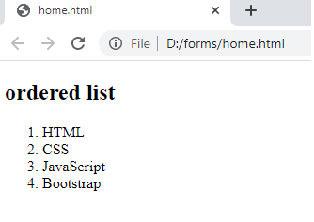

Ordered HTML List - The Type Attribute

The type attribute of the <ol> tag, defines the type of the list item marker:

type=”1” numbers (default)

Type=”A” upper case letters.

Type=”a” lower case letters.

Type=”I” upper case roman numbers.

Type=”i” lower case roman numbers.

Ex:

<!DOCTYPE html>

<html>

<body>

<h2> ordered list</h2>

<ol type="A">

<li>HTML</li>

<li>CSS</li>

<li>JavaScript</li>

<li>Bootstrap</li>

</ol>

</body>

</html>

|  |  |
| --- | --- |
| **Output:**  **Untitled.png**  **Ex:**  <!DOCTYPE html>  <html>  <body>  <h2> ordered list</h2>  <ol type="i">  <li>HTML</li>  <li>CSS</li>  <li>JavaScript</li>  <li>Bootstrap</li>  </ol>  </body>  </html> |  |

Output:

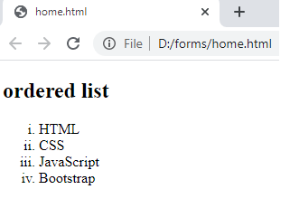

Control List Counting

By default, an ordered list will start counting from 1. If you want to start counting from a specified number, you can use the start attribute:

Ex:

<!DOCTYPE html>

<html>

<body>

<h2> ordered list</h2>

<ol start="100">

<li>HTML</li>

<li>CSS</li>

<li>JavaScript</li>

<li>Bootstrap</li>

</ol>

</body>

</html>

Output:

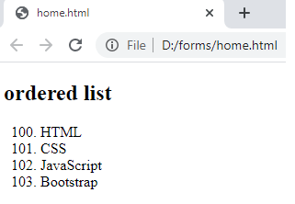

Nested HTML Lists

Lists can be nested (list inside list):

Ex:

<!DOCTYPE html>

<html>

<head>

<title> unordered list </title>

</head>

<body>

<ol>

<li> HTML </li>

<li> CSS </li>

<li> BOOTSTRAP

<ol>

<li> it is very easy to learn </li>

<li> mobile friendly </li>

</ol>

</li>

<li> javascript </li>

<li> php

<ul>

<li> server side scripting language

<ol>

<li> asp

<ul>

<li> server pages </li>

<li> microsoft related </li>

</ul>

</li>

<li> jsp </li>

<li> php </li>

</ol>

</li>

<li> open source technology </li>

</ul>

</li>

<li> mysql </li>

</ol>

</body>

</html>

Output:

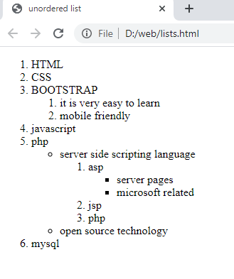

**Note:** A list item (<li>) can contain a new list, and other HTML elements, like images and links, etc

## HTML Description Lists

A description list is a list of terms, with a description of each term.

The [<dl>](https://www.w3schools.com/tags/tag_dl.asp) tag defines the description list, the [<dt>](https://www.w3schools.com/tags/tag_dt.asp) tag defines the term (name), and the [<dd>](https://www.w3schools.com/tags/tag_dd.asp) tag describes each term:

Ex:

<!DOCTYPE html>

<html>

<head>

<title> unordered list </title>

</head>

<body>

<dl>

<ol>

<li> <dt> India </dt> </li>

<dd> India (Hindi: Bhārat), officially the Republic of India (Hindi: Bhārat Gaṇarājya),[23] is a country in South Asia. It is the second-most populous country, the seventh-largest country by land area, and the most populous democracy in the world. Bounded by the Indian Ocean on the south, the Arabian Sea on the southwest, and the Bay of Bengal on the southeast, it shares land borders with Pakistan to the west;[f] China, Nepal, and Bhutan to the north; and Bangladesh and Myanmar to the east. In the Indian Ocean, India is in the vicinity of Sri Lanka and the Maldives; its Andaman and Nicobar Islands share a maritime border with Thailand and Indonesia. </dd>

<li> <dt> Japan </dt> </li>

<dd>Japan (Japanese: 日本, Nippon [ɲippoꜜɴ] (About this soundlisten) or Nihon [ɲihoꜜɴ] (About this soundlisten)) is an island country in East Asia located in the northwest Pacific Ocean. It is bordered by the Sea of Japan to the west and extends from the Sea of Okhotsk in the north to the East China Sea and Taiwan in the south. Part of the Pacific Ring of Fire, Japan comprises an archipelago of 6,852 islands covering 377,975 square kilometers (145,937 sq mi); the country's five main islands, from north to south, are Hokkaido, Honshu, Shikoku, Kyushu, and Okinawa. Tokyo is Japan's capital and largest city; other major cities include Yokohama, Osaka, Nagoya, Sapporo, Fukuoka, Kobe, and Kyoto. </dd>

</ol>

</dl>

</body>

</html>

Output:

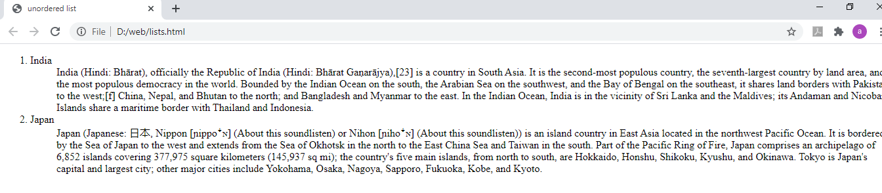

# Head Element

The HTML <head> element is a container for the following elements: <title>, <style>, <meta>, <link>, <script>.

The HTML <head> Element

The <head> element is a container for metadata (data about data) and is placed between the <html> tag and the <body> tag.

HTML metadata is data about the HTML document. Metadata is not displayed.

Metadata typically define the document title, character set, styles, scripts, and other meta information.

The HTML <title> Element

The <title> element defines the title of the document. The title must be text-only, and it is shown in the browser's title bar or in the page's tab.

The <title> tag is required in HTML documents!

The contents of a page title is very important for search engine optimization (SEO)! The page title is used by search engine algorithms to decide the order when listing pages in search results.

So, try to make the title as accurate and meaningful as possible!

Ex:

<!DOCTYPE html>

<html>

<head>

<title>A Meaningful Page Title</title>

</head>

<body>

<p>The content of the body element is

displayed in the browser window.</p>

<p>The content of the title element is displayed in

the browser tab, in favorites and in search-engine results.</p>

</body>

</html>

Output:

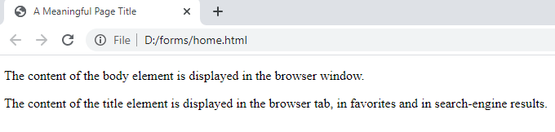

Adding a favicon in title tag ?

Favicon should represent your business or company logo.

It is also called as favicon or url icon or website icon.

Plz take care of the size of favicon, it should be 16 *16 or 32 * 32 px. If you take more than this, it will treat 32*32.

Ex:

<!DOCTYPE html>

<html>

<head>

<title>India</title>

<link href="images/indianflag.png" rel="icon" type="image/ico">

</head>

<body>

<h1>About India</h1>

<p>India is a great country</p>

<p>India is the largest democratic country in the world</p>

</body>

</html>

Output:

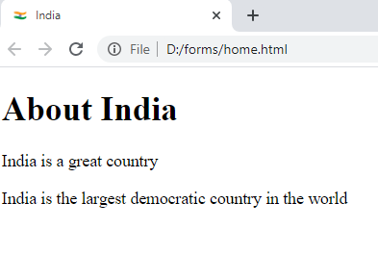

In the above output you can able to see the Indian flag as favicon in the title bar.

# <meta> Tag

The <meta> tag defines metadata about an HTML document. Metadata is data (information) about data.

<meta> tags always go inside the <head> element, and are typically used to specify character set, page description, keywords, author of the document, and viewport settings.

Metadata will not be displayed on the page, but is machine parsable.

Metadata is used by browsers (how to display content or reload page), search engines (keywords), and other web services.

Ex:

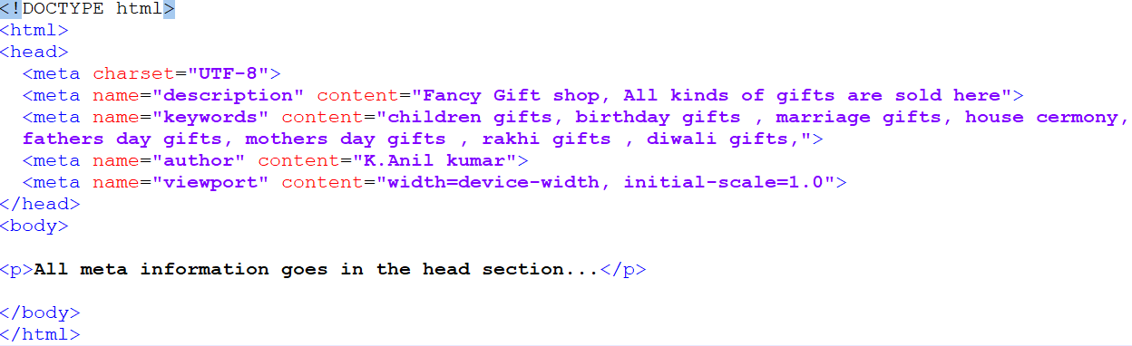

Output:

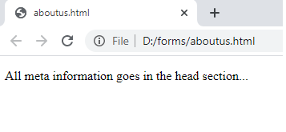

In the above example, meta data will used by SEO & browser.

**Define keywords for search engines:**

<meta name="keywords" content="children gifts, birthday gifts , marriage gifts, house cermony,

fathers day gifts, mothers day gifts , rakhi gifts , diwali gifts">

**Define a description of your web page:**

<meta name="description" content="Fancy Gift shop, All kinds of gifts are sold here">

**Define the author of a page:**

<meta name="author" content="K.Anil kumar">

# HTML Entities

Some characters are reserved in HTML.

If you use the less than (<) or greater than (>) signs in your text, the browser might mix them with tags.

Character entities are used to display reserved characters in HTML.

Syntax:

&*entity_name*;

OR

&#*entity_number*;

To display a less than sign (<) we must write: **&lt;** or **&#60;**

Non-breaking Space

A commonly used entity in HTML is the non-breaking space: **&nbsp;**

A non-breaking space is a space that will not break into a new line.

Two words separated by a non-breaking space will stick together (not break into a new line). This is handy when breaking the words might be disruptive.

Examples:

* § 10
* 10 km/h
* 10 PM

Another common use of the non-breaking space is to prevent browsers from truncating spaces in HTML pages.

If you write 10 spaces in your text, the browser will remove 9 of them. To add real spaces to your text, you can use the **&nbsp;** character entity.

Ex:

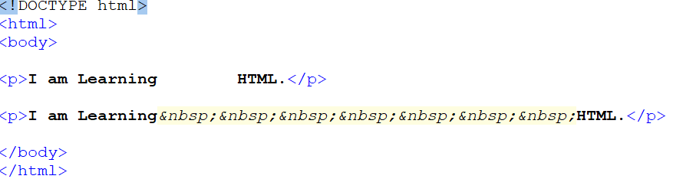

In the above example in first paragraph , i gave space between Learning & HTML ,

but in output you wont able to see the space as browser will remove the space and gives only one space between Learning & HTML. But in the second paragraph i used &nbsp; ( non breaking space HTML Entity), so the browser allocates 7 space between Learning & HTML as i used &nbsp; 7 times.

Output:

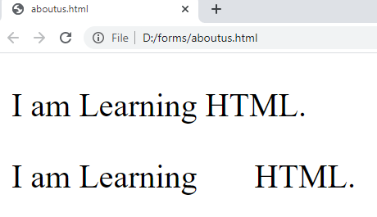

In the same we can use for

< (less than) &lt; or &#60;

> (greather than) &gt or &#62;

© (copyright) &copy; or &#169

® (registered trademark) &reg; or &#174

**₹ (Indian rupee)** &#x20B9;

Ex:

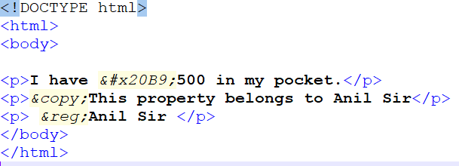

Output:

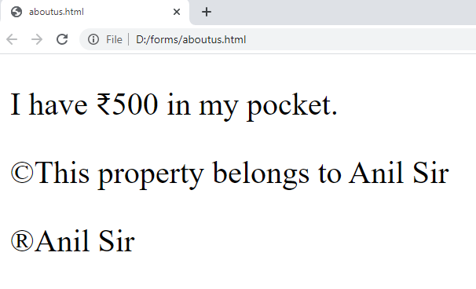

Div & span

Every HTML element has a default display value, depending on what type of element it is.

There are two display values: block and inline.

A block-level element always starts on a new line and takes up the full width available (stretches out to the left and right as far as it can).

The <div> element is a block-level element.

An inline element does not start on a new line and it only takes up as much width as necessary.

This is a <span> element inside a paragraph.

The <div> element is often used as a container for other HTML elements.

The <div> element has no required attributes, but style, class and id are common.

When used together with CSS, the <div> element can be used to style blocks of content:

Ex:

<!DOCTYPE html>

<html>

<body>

<div style="background-color:yellow;color:white;padding:20px; color:blue;">

<h2>India</h2>

<p>India is a great Country</p>

<p>India is the largest democratic country in the world</p>

</div>

</body>

</html>

Output:

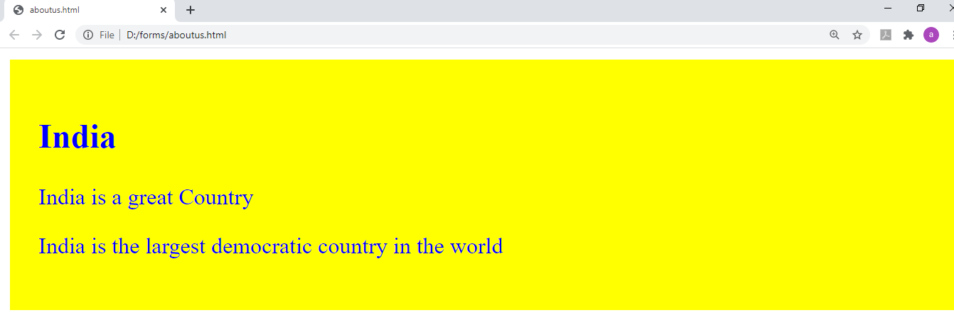

The <span> Element

The <span> element is an inline container used to mark up a part of a text, or a part of a document.

The <span> element has no required attributes, but style, class and id are common.

When used together with CSS, the <span> element can be used to style parts of the text:

Ex:

<!DOCTYPE html>

<html>

<body>

<div style="background-color:yellow;color:white;padding:20px; color:blue;">

<h2>India</h2>

<p>India is a great Country</p>

<p>India is the <span style="color:#db1a71;font-size:26px;font-family:Monotype Corsiva;"> largest democratic country</span> in the world</p>

</div>

</body>

</html>

Output:

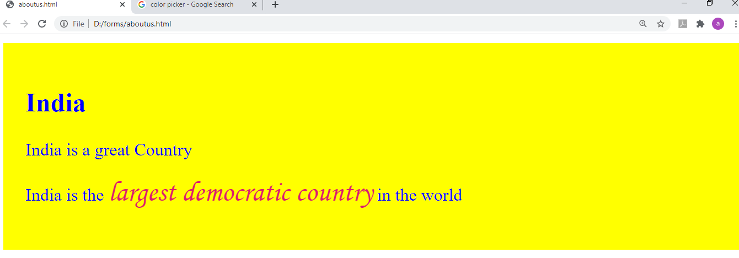

Iframe

An HTML iframe is used to display a web page within a web page.

Syntax

The HTML <iframe> tag specifies an inline frame.

An inline frame is used to embed another document within the current HTML document.

<iframe src="*url*" title="description">

Set Height and Width

Use the height and width attributes to specify the size of the iframe.

The height and width are specified in pixels by default:

<iframe src=" http://www.nist.edu/” " height="200" width="300" title="nist college"></iframe>

Or you can add the style attribute and use the CSS height and width properties:

<iframe src=" http://www.nist.edu/” style=”width:200px; height:300px;”title="nist college"></iframe>

Remove the Border

By default, an iframe has a border around it.

To remove the border, add the style attribute and use the CSS border property:

<iframe src=" http://www.nist.edu/” style=”border:none;” title="nist college"></iframe>

Ex:

<!DOCTYPE html>

<html>

<body>

<h1> Example regading iframe</h1>

<p> If you observe, we are opening nist website in our page (by allocating some space) </p>

<iframe src=" http://www.nist.edu/" style="width:600px;height:400px;" title="nist college"></iframe>

</body>

</html>

Output:

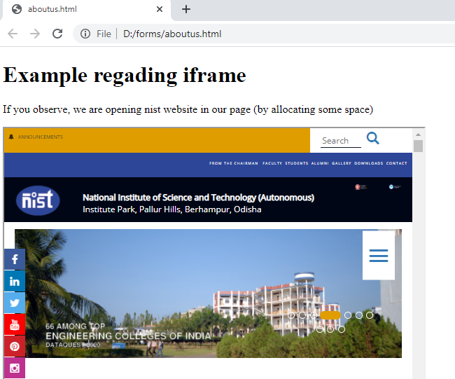

Ex:2

In this example i am trying to open flipkart website in an iframe.

<!DOCTYPE html>

<html>

<body>

<h1> Example regading iframe</h1>

<p> If you observe, we are opening flipkart website in our page (by allocating some space) </p>

<p> the flipkart prevents to open in an iframe, so the site not opening in iframe </p>

<iframe src="http://www.flipkart.com/" style="width:600px;height:400px;" title="flipkart"></iframe>

</body>

</html>

Output:

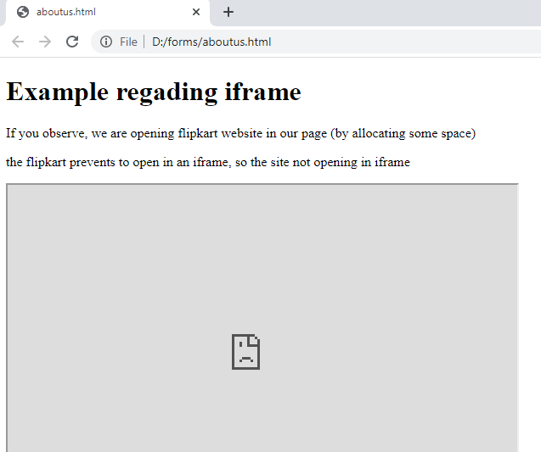

Some websites doesn’t open in iframes, if you try to open then we will get broken symbol as i got above.

_parent & _top

_parent opens the linked document in the parent frame.

_top opens the linked document in the full body of the window

Ex:

A3.html

Code:

<!doctype html>

<html>

<head>

<title> a3</title>

</head>

<body>

<h1> This is a3 </h1>

<p> India is a great country </p>

<p><a href="http://www.nist.edu/index.php" target="_parent"> nist </a> ( _parent ) </p><br><br>

<p><a href="https://www.smitorissa.org/" target="_top"> smit </a>( _top ) </p>

</body>

</html>

A2.html

Code:

<!doctype html>

<html>

<head>

<title> a2</title>

</head>

<body>

<h1> Hello this a2 </h1>

<iframe src="a3.html" width="500" height="300" style="border-color:red;"> </iframe>

</body>

</html>

A1.html

Code:

<!doctype html>

<html>

<head>

<title> a1</title>

</head>

<body>

<h1> Hello this is a1 </h1>

<iframe src="a2.html" width="800" height="500" style="border-color:red;"> </iframe>

</body>

</html>

Output:

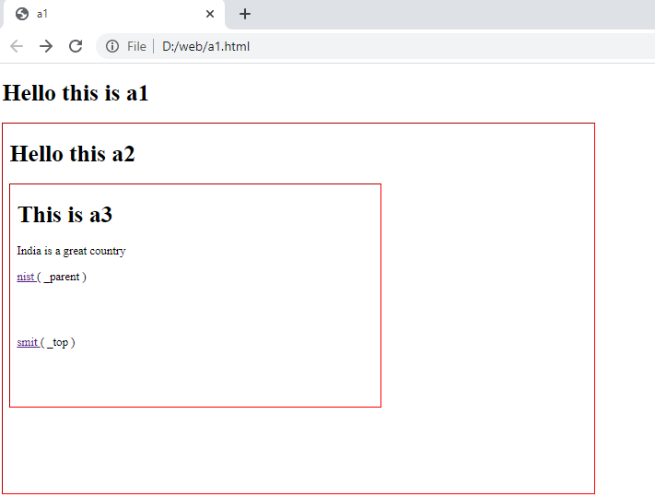

If we click on nist. The output will be

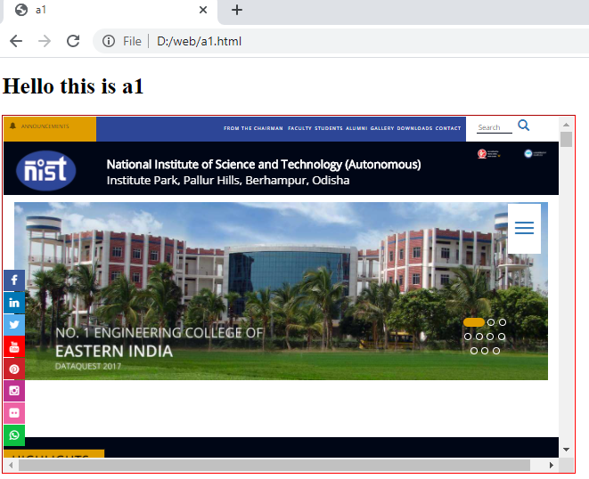

For example if we clicked on smit. The outputwill be

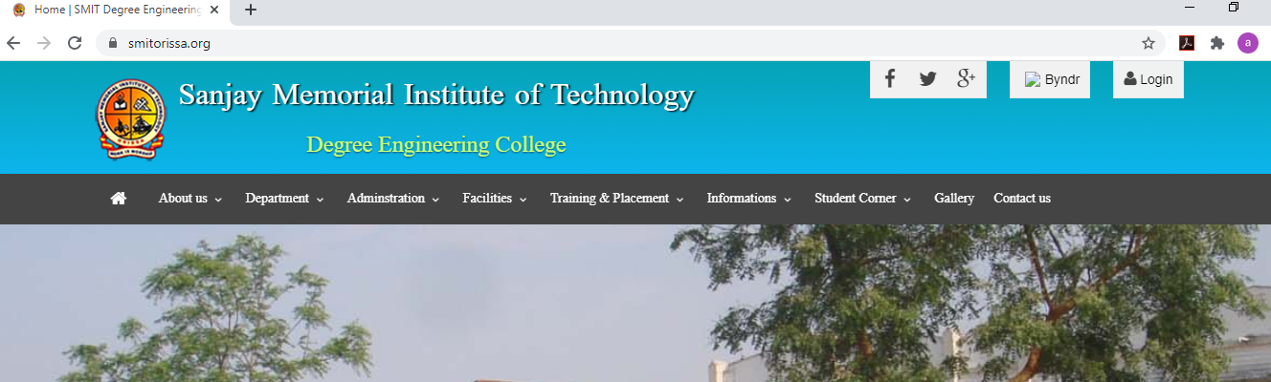

How to make a file downloadable in html ?

Download file when clicking on the link (instead of navigating to the file):

Syntax

<a href=”file which you want to download” download > any text/ image </a>

Ex 1:

<a href="images/Notification-CSPE_2020_N_Engl.pdf" download> Click here to download notification </a>

Ex2.

<a href="images/amazon-iStock-1044285108.jpg" download> <img src="images/unnamed.png" height="100" width="200"> </a>

Note:

Inorder to make this downloadable work, place the html file in a server, then you see the output .

Example program.

I am placing the below program in server. In location the location C:\xampp\htdocs\myproject

Code:

<!DOCTYPE html>

<html>

<body>

<h1> Download your favorite pictures </h1>

<a href="images/amazon-iStock-1044285108.jpg" download> <img src="images/unnamed.png" height="100" width="200"> </a>

<br><br>

<a href="images/rkojavqo0o.jpg" download> Click here to download parrot pic </a>

<br><br>

<a href="images/Notification-CSPE_2020_N_Engl.pdf" download> Click here to download notification </a>

<br><br>

<a href="images/Ae_Mere_Dil_Abhay_Jodhpurkar.mp3" download> Click here to download Ae_Mere_Dil_Abhay_Jodhpurkar song </a>

</body>

</html>

Output:

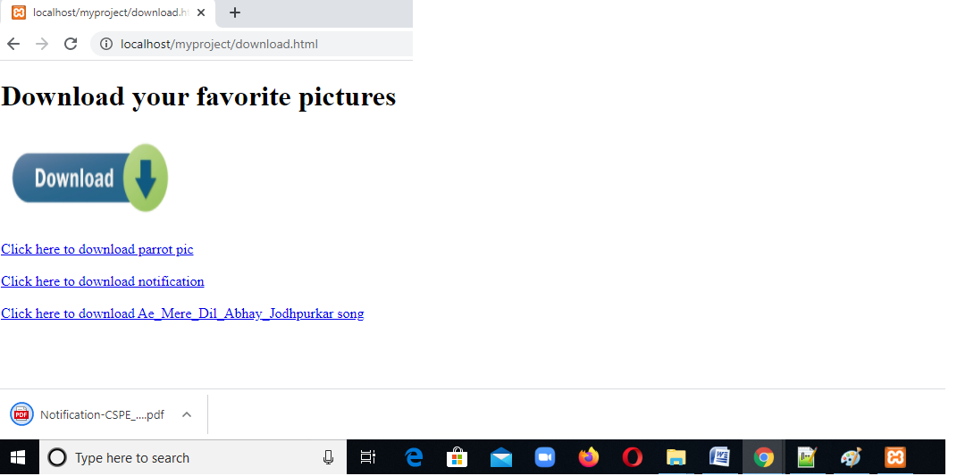

# HTML Multimedia

Multimedia on the web is sound, music, videos, movies, and animations.

Multimedia comes in many different formats. It can be almost anything you can hear or see, like images, music, sound, videos, records, films, animations, and more.

Web pages often contain multimedia elements of different types and formats.

# HTML Video :

The HTML <video> element is used to show a video on a web page.

Ex:

<!DOCTYPE html>

<html>

<head>

<title> Video </title>

</head>

<body>

<video height="400" width="400" controls>

<source src="robot-mp4-file.mp4" type="video/mp4">

Your browser does not support the video tag.

</video>

</body>

</html>

Output:

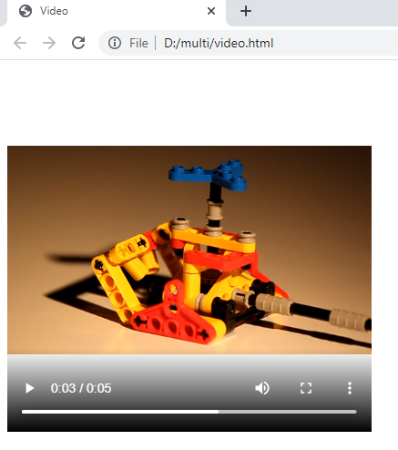

The controls attribute adds video controls, like play, pause, and volume.

It is a good idea to always include width and height attributes. If height and width are not set, the page might flicker while the video loads.

The <source> element allows you to specify alternative video files which the browser may choose from. The browser will use the first recognized format.

The text between the <video> and </video> tags will only be displayed in browsers that do not support the <video> element.

# HTML Audio

The HTML <audio> element is used to play an audio file on a web page.

To play an audio file in HTML, use the <audio> element:

Ex:

<!DOCTYPE html>

<html>

<head>

<title> Audio </title>

<style>

audio{

margin-top:40px;

margin-left:50px;

}

</style>

</head>

<body>

<audio controls>

<source src="Ae_Mere_Dil_Abhay_Jodhpurkar.mp3" type="audio/mp3">

Your browser does not support the audio tag.

</audio>

</body>

</html>

Output:

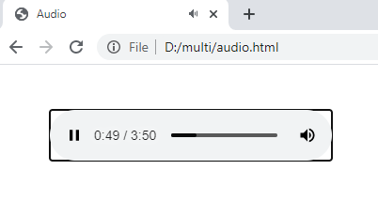

The controls attribute adds audio controls, like play, pause, and volume.

The <source> element allows you to specify alternative audio files which the browser may choose from. The browser will use the first recognized format.

The text between the <audio> and </audio> tags will only be displayed in browsers that do not support the <audio> element.

# HTML YouTube Videos

The easiest way to play videos in HTML, is to use YouTube.

Adding an youtube video:

Step1:

Open youtube -> open the video which you want to display in your webpage .

For example, I want to show apple iphone 12 official trailer in my website.

* Open the iphone 12 official trailer in youtube.
* Then click on share
* Then click on embed
* Now copy the embed video code.
* Paste the code in your webpage.

Ex:

<!DOCTYPE html>

<html>

<head>

</head>

<body>

<iframe width="560" height="315" src="https://www.youtube.com/embed/cnXapYkboRQ" frameborder="0" allow="accelerometer; autoplay; clipboard-write; encrypted-media; gyroscope; picture-in-picture" allowfullscreen></iframe>

</body>

</html>

Output:

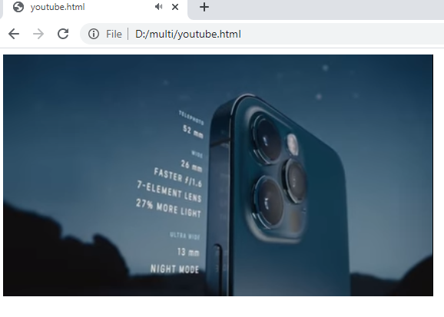

YouTube Autoplay + Mute

You can let your video start playing automatically when a user visits the page, by adding autoplay=1 to the YouTube URL.

**Note:** Automatically starting a video can annoy your visitor and end up causing more harm than good!

Chrome added stricter autoplay policies in 2018. Chromium browsers do not allow autoplay in all cases. However, muted autoplay is always allowed.

Add mute=1 after autoplay=1 to let your video start playing automatically (but muted).

Ex:

<!DOCTYPE html>

<html>

<head>

</head>

<body>

<iframe width="560" height="315" src="https://www.youtube.com/embed/cnXapYkboRQ?autoplay=1&mute=1" ></iframe>

</body>

</html>

Output:

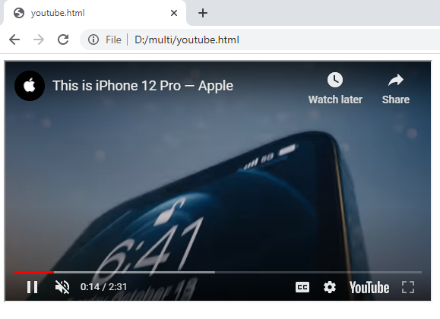

**How to add google map to website**

1. Go to **maps**.**google**.com. Type the location in the search box and click on Share.
2. In the new window click on **Embed** a **map** and copy the HTML code of the **map**.

Ex:

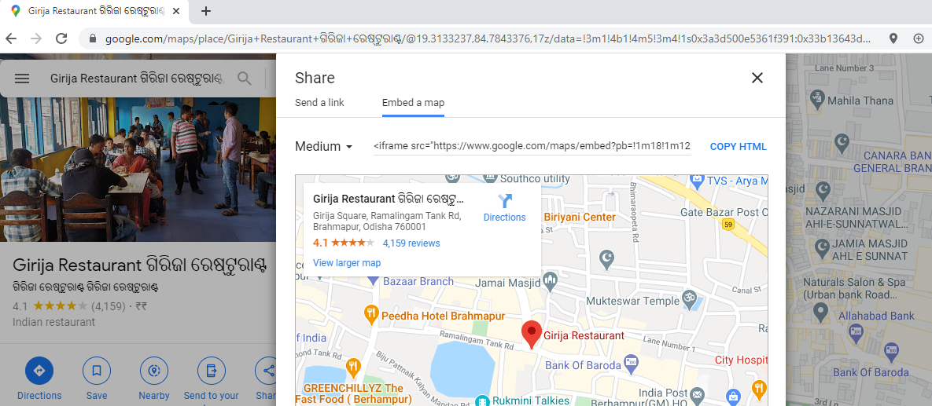

Code:

<!DOCTYPE html>

<html>

<head>

</head>

<body>

<h1> Girija Restaurant </h1>

<iframe src="https://www.google.com/maps/embed?pb=!1m18!1m12!1m3!1d3765.2875724979767!2d84.7843376143803!3d19.31332374948975!2m3!1f0!2f0!3f0!3m2!1i1024!2i768!4f13.1!3m3!1m2!1s0x3a3d500e5361f391%3A0x33b13643d297a673!2zR2lyaWphIFJlc3RhdXJhbnQg4KyX4Ky_4Kyw4Ky_4Kyc4Ky-IOCssOCth-Cst-CtjeCsn-CtgeCssOCsvuCso-CtjeCsnw!5e0!3m2!1sen!2sin!4v1606640246613!5m2!1sen!2sin" width="600" height="450" frameborder="0" style="border:0;" allowfullscreen="" aria-hidden="false" tabindex="0"></iframe>

</body>

</html>

Output:

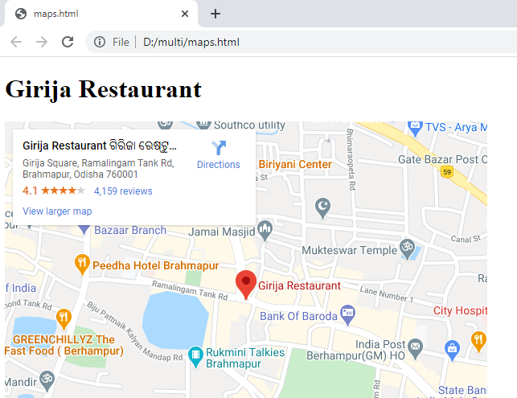

# HTML Forms

An HTML form is used to collect user input. The user IS sent to a server for processing.

The HTML <form> element is used to create an HTML form for user input:

Syntax:

<form>  
  
*form elements*  
  
</form>

The <form> element is a container for different types of input elements, such as: text fields, checkboxes, radio buttons, submit buttons, etc.

# Form Attributes:

1. The Action Attribute:

The action attribute defines the action to be performed when the form is submitted.

Usually, the form data is sent to a file on the server when the user clicks on the submit button.

<form action=”home.php”>

</form>

1. Target Attribute

The target attribute specifies where to display the response that is received after submitting the form

<form action=”home.php” target=”_blank”>

</form>

## Method Attribute

The method attribute specifies the HTTP method to be used when submitting the form data.

The form-data can be sent as URL variables (with method="get") or as HTTP post transaction (with method="post").

The default HTTP method when submitting form data is GET.

<form action=”home.php” target=”_blank” method=”POST”>

</form>

## GET vs POST

**GET:**

* Appends the form data to the URL, in name/value pairs
* NEVER use GET to send sensitive data! (the submitted form data is visible in the URL!)
* The length of a URL is limited (2048 characters)
* GET is good for non-secure data, like query strings in Google

**POST:**

* Appends the form data inside the body of the HTTP request (the submitted form data is not shown in the URL)
* POST has no size limitations, and can be used to send large amounts of data.
* Form submissions with POST cannot be bookmarked

Always use POST if the form data contains sensitive or personal information!

1. Autocomplete Attribute

The autocomplete attribute specifies whether a form should have autocomplete on or off.

When autocomplete is on, the browser automatically complete values based on values that the user has entered before.

<!DOCTYPE html>

<html>

<body>

<form action="home.php">

<label for="fname">First name:</label>

<input type="text" id="fname" name="fname" autocomplete="on"><br><br>

<label for="lname">Last name:</label>

<input type="text" id="lname" name="lname" autocomplete="off"><br><br>

<input type="submit">

</form>

</body>

</html>

Output:

Observe for the first name field you will get suggestions because for the first name field we set autocomplete feature on. Whereas for the last name field we will not get suggestions as we set autocomplete feature to off .

Note:

We can set autocomplete=”on/off” for an element individually or directly to the form tag at once.

<form>

<input type="text" id="fname" name="fname" autocomplete="on">

</form>

Or

<form autocomplete=”off”>

<input type="text" id="fname" name="fname">

<input type="text" id="lname" name="lname">

</form>

By default autocomplete feature will be in on state.

 HTML <form> Elements

The HTML <form> element can contain one or more of the following form elements:

* <input>
* <label>
* <select>
* <textarea>
* <button>
* <fieldset>
* <legend>
* <datalist>
* <option>

The <label> Element

The <label> element defines a label for several form elements.

The <label> element is useful for screen-reader users, because the screen-reader will read out loud the label when the user focus on the input element.

The <label> element also help users who have difficulty clicking on very small regions (such as radio buttons or checkboxes) - because when the user clicks the text within the <label> element, it toggles the radio button/checkbox.

The for attribute of the <label> tag should be equal to the id attribute of the <input> element to bind them together.

Ex:

<label for="fname">First name:</label>  
<input type="text" id="fname" name="fname">

The <input> Element :

One of the most used form element is the <input> element.

The <input> element can be displayed in several ways, depending on the type attribute.

Use name & value attributes.

Using name attribute we can retrieve the value of element in server.

Some elements like radio , checkbox we should give value attribute compulsory, so that we can get the value at server side.

Input Type text

<input type=”text”> or <input>

<input type="text">  or <input> defines a **single-line text input field**:

Ex:

<!DOCTYPE html>

<html>

<body>

<h1> Text Field </h1>

<form action="home.php">

<label for="fname">First name:</label>

<input type="text" id="fname" name="fname"><br><br>

<label for="lname">Last name:</label>

<input type="text" id="lname" name="lname"><br><br>

<input type="submit">

</form>

</body>

</html>

Output:

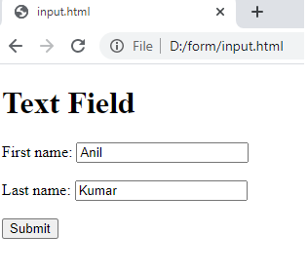

Input Type Password

<input type="password"> defines a **password field**:

Ex:

<!DOCTYPE html>

<html>

<body>

<h1> Password Field </h1>

<form action="home.php">

<label for="uname">User Name:</label>

<input type="text" id="uname" name="uname"><br><br>

<label for="pwd">Password:</label>

<input type="password" id="pwd" name="pwd"><br><br>

<input type="submit">

</form>

</body>

</html>

Output:

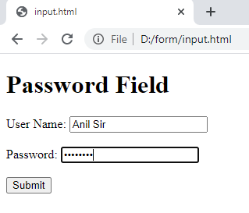

Input Type Radio

<input type="radio"> defines a **radio button**.

Radio buttons let a user select ONLY ONE of a limited number of choices:

Ex:

<!DOCTYPE html>

<html>

<body>

<h1> Radio Button </h1>

<form action="home.php">

<input type="radio" id="male" name="gender" value="male">

<label for="male">Male</label><br>

<input type="radio" id="female" name="gender" value="female">

<label for="female">Female</label><br><br>

<input type="submit" value="Submit">

</form>

</body>

</html>

Output:

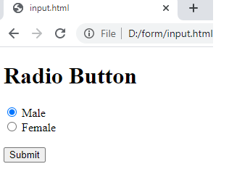

Note 1: to group certain radio buttons keep name attribute value same , in this example we kept name=”gender” .

Note 2: Keep value attribute also, so the value of the selected radio button will be received in the server.

Input Type checkbox

<input type="checkbox"> defines a **checkbox**.

Checkboxes let a user select ZERO or MORE options of a limited number of choices.

Ex:

<!DOCTYPE html>

<html>

<body>

<h2>Checkboxes</h2>

<form action="home.php"">

<label> languages Known : </label>

<input type="checkbox" id="odi" name="odi" value="odia">

<label for="odi"> Odiya</label>

<input type="checkbox" id="hin" name="hin" value="Hindi">

<label for="hin"> Hindi</label>

<input type="checkbox" id="eng" name="eng" value="english">

<label for="eng"> English</label> <br><br>

<input type="submit" value="Submit">

</form>

</body>

</html>

Output:

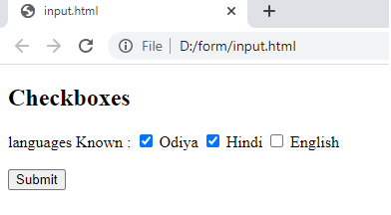

Input Type date

The <input type="date"> is used for input fields that should contain a date.

Depending on browser support, a date picker can show up in the input field.

Ex:

<!DOCTYPE html>

<html>

<body>

<h2>Date Field</h2>

<form action="home.php">

<label for="bday">Birthday:</label>

<input type="date" id="bday" name="bday">

<input type="submit" value="Submit">

</form>

</body>

</html>

Output:

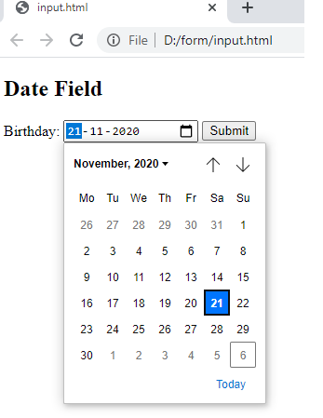

You can also use the min and max attributes to add restrictions to dates:

Ex:

<!DOCTYPE html>

<html>

<body>

<h2>Date Field</h2>

<form action="home.php">

<label for="datemax">Enter a date before 1980-01-01:</label>

<input type="date" id="datemax" name="datemax" max="1979-12-31"><br><br>

<label for="datemin">Enter a date after 2000-01-01:</label>

<input type="date" id="datemin" name="datemin" min="2000-01-02"><br><br>

<input type="submit" value="Submit">

</form>

</body>

</html>

Output:

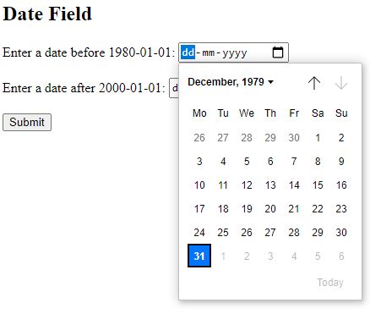

Input Type Email

The <input type="email"> is used for input fields that should contain an e-mail address.

Ex:

<!DOCTYPE html>

<html>

<body>

<h2>email field</h2>

<form action="home.php">

<label for="email">Enter your email:</label>

<input type="email" id="email" name="email" required>

<br><br><br><br><br>

<input type="submit" value="Submit">

</form>

</body>

</html>

Output 1:

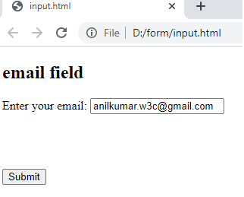

Output 2:

Gave wrong email id ( syntactically wrong email id )

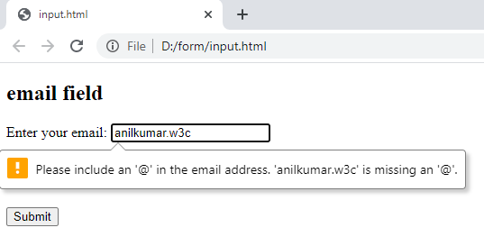

# HTML <input> required Attribute

The required attribute is a boolean attribute.

When present, it specifies that an input field must be filled out before submitting the form.

**Note:** The required attribute works with the following input types: text, search, url, tel, email, password, date pickers, number, checkbox, radio, and file.

Ex:

<!DOCTYPE html>

<html>

<body>

<h1>The input required attribute</h1>

<form action="home.php">

<label for="username">Username:</label>

<input type="text" id="username" name="username" required>

<br><br>

<input type="submit">

</form>

</body>

</html>

Output:

I didn’t entered any value in the input field and clicked submit button,

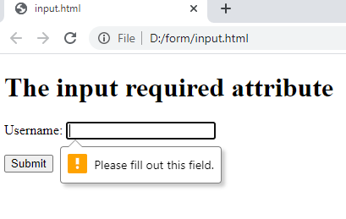

Input Type File

The <input type="file"> defines a file-select field and a "Browse" button for file uploads.

Ex:

<!DOCTYPE html>

<html>

<body>

<h1>File upload</h1>

<p>Show a file-select field which allows a file to be chosen for upload:</p>

<form action="home.php">

<label for="myfile">Select a file:</label>

<input type="file" id="myfile" name="myfile"><br><br>

<input type="submit" value="Submit">

</form>

</body>

</html>

Output:

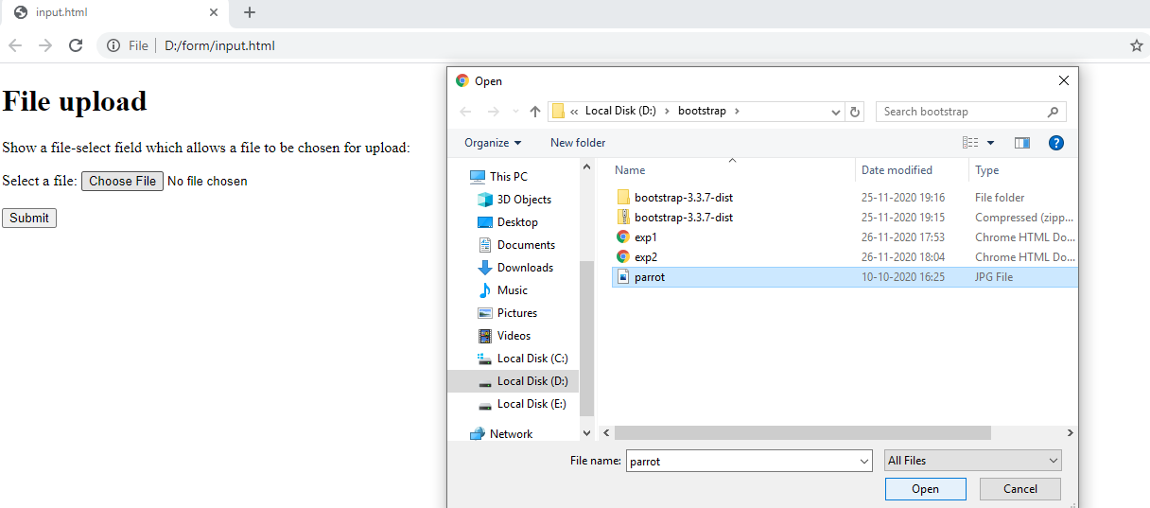

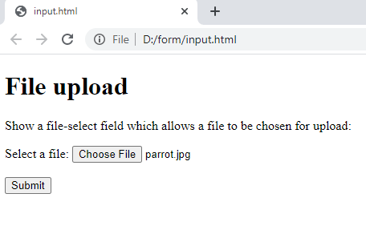

# HTML <input> accept Attribute

The accept attribute specifies a filter for what file types the user can pick from the file input dialog box (only for type="file").

**Note:** The accept attribute can only be used with <input type="file">.

**Tip:** Do not use this attribute as a validation tool. File uploads should be validated on the server.

Ex:

<!DOCTYPE html>

<html>

<body>

<h1>The input accept attribute</h1>

<form action="home.php">

<label for="img">Select image:</label>

<input type="file" id="img" name="img" accept="image/*">

<br><br>

<input type="submit">

</form>

</body>

</html>

Output:

In this example, the user can able to select only image files. He can’t able select other file like ( .doc , .docx , .xls , .html ,…. Etc )

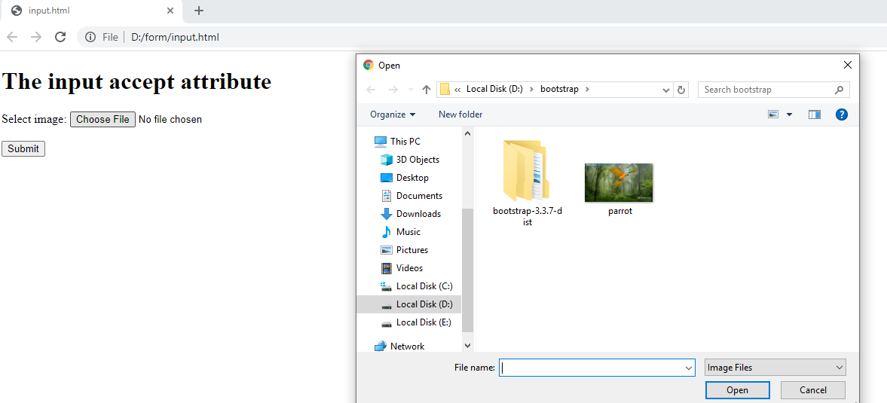

# HTML multiple Attribute

When multiple attribute is present, it specifies that the user is allowed to enter/select more than one value.

A file upload field that accepts multiple files:

Ex:

<!DOCTYPE html>

<html>

<body>

<h1>The input multiple attribute</h1>

<p>Try selecting more than one file when browsing for files.</p>

<form action="home.php">

<label for="files">Select files:</label>

<input type="file" id="files" name="files" multiple>

<br><br>

<input type="submit">

</form>

</body>

</html>

Output:

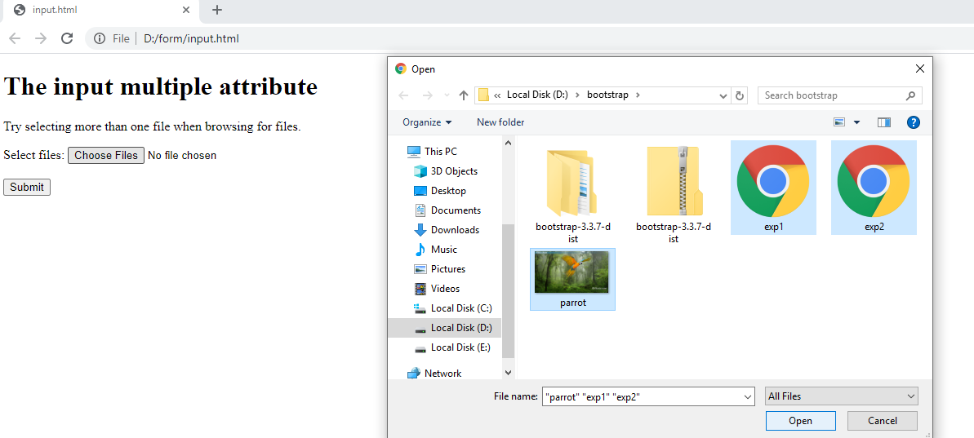

After selecting 3 files , the output will be

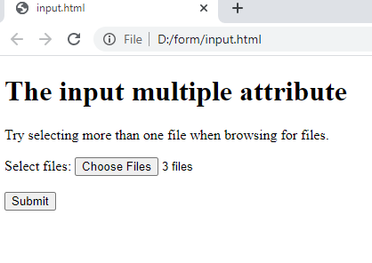

Input Type Submit

<input type="submit"> defines a button for **submitting** form data to a **form-handler**.

The form-handler is typically a server page with a script for processing input data.

The form-handler is specified in the form's action attribute:

Ex:

For your understanding purpose I used method=”GET” and in action attribute I used dummy html file, So that I can show you how submit works.

Ex:

<!DOCTYPE html>

<html>

<body>

<h2>Submit Button</h2>

<p>The <strong>input type="submit"</strong> defines a button for submitting form data to a form-handler:</p>

<form method="GET" action="result.html">

<label for="fname">First name:</label><br>

<input type="text" id="fname" name="fname"><br>

<label for="lname">Last name:</label><br>

<input type="text" id="lname" name="lname"><br><br>

<input type="submit" value="Submit">

</form>

<p>If you click "Submit", the form-data will be sent to a page called "result.html".</p>

</body>

</html>

Output:

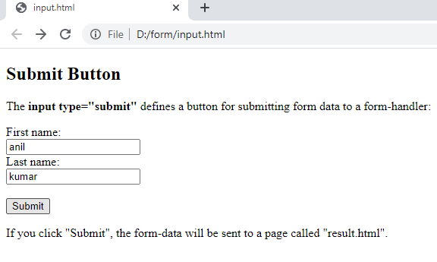

I entered two values and clicked on submit , then it will take to result.html page, the output will be ..

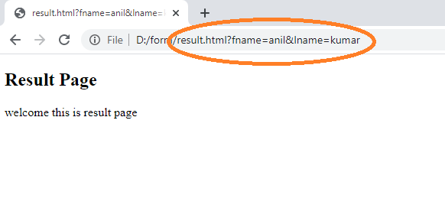

You can observe in the title bar, the values of fname & lname.

Input Type Reset

<input type="reset"> defines a **reset button** that will reset all form values to their default values:

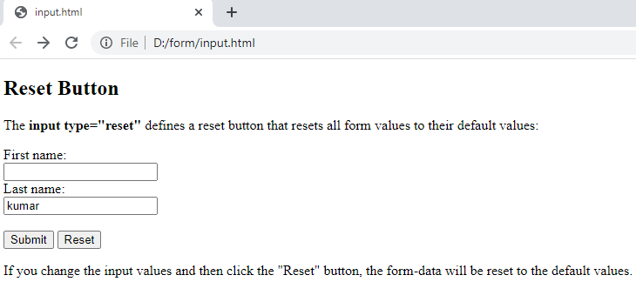

Now I entered some value for first name & changed the value of last name.

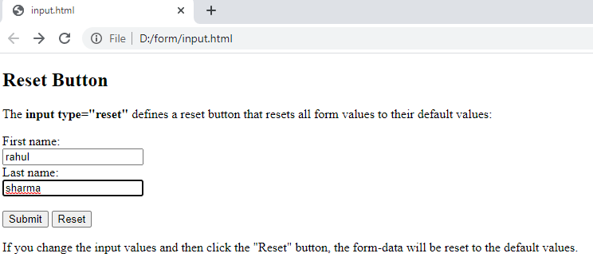

Now I will click on reset button, then the output will be.

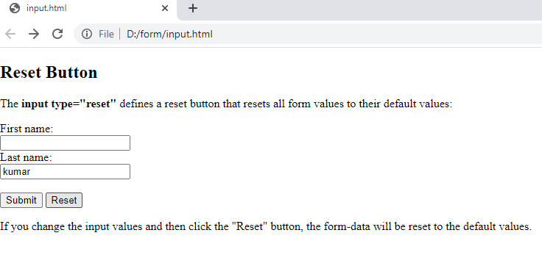

# HTML <input type="image">

The <input type="image"> defines an image as a submit button.

The path to the image is specified in the src attribute.

Ex:

<!DOCTYPE html>

<html>

<body>

<h1>Display an Image as the Submit button</h1>

<form action="result.html">

<label for="fname">First name: </label>

<input type="text" id="fname" name="fname"><br><br>

<label for="lname">Last name: </label>

<input type="text" id="lname" name="lname"><br><br>

&nbsp;&nbsp;&nbsp;&nbsp;&nbsp;&nbsp;&nbsp;&nbsp;&nbsp;&nbsp;&nbsp;&nbsp;

<input type="image" src="images/animated-submit-button.gif" alt="Submit" width="150" height="48">

</form>

</body>

</html>

Output:

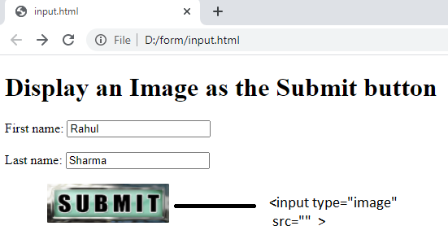

If you click on the submit , then it will take values to result.html page

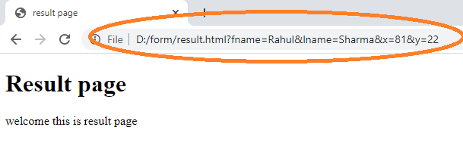

The Name Attribute for <input>

Notice that each input field must have a name attribute to be submitted.

If the name attribute is omitted, the value of the input field will not be sent at all.

Ex:

<!DOCTYPE html>

<html>

<body>

<h2>The name Attribute</h2>

<form action="result.html" method="GET">

<label for="fname">First name:</label><br>

<input type="text" id="fname"><br><br>

<label for="lname">Last name:</label><br>

<input type="text" id="lname" name="lname"><br><br>

<input type="submit" value="Submit">

</form>

<p>If you click the "Submit" button, the form-data will be sent to a page called "/action_page.php".</p>

<p>Notice that the value of the "First name" field will not be submitted, because the input element does not have a name attribute.</p>

<p> Notice that the value of the "Last Name" field will be submitted </p>

</body>

</html>

Output:

In the first name field I gave anil & in the last name field I gave kumar as values.

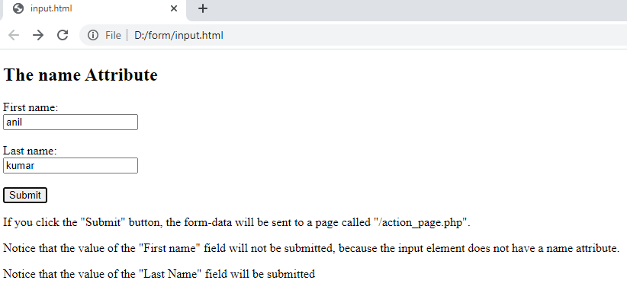

Now click on submit, you will observe that only last name field value only submitted , whereas the first name field will not be submitted as first name field doesn’t have name attribute.

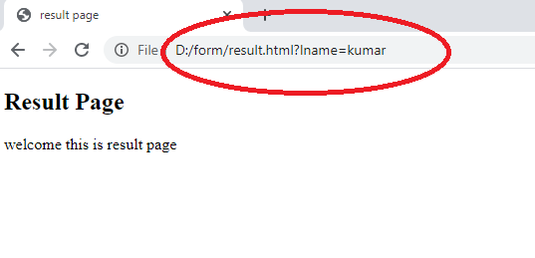

Input Restrictions

Checked

Specifies that an input field should be pre-selected when the page loads (for type="checkbox" or type="radio")

Ex:

<!DOCTYPE html>

<html>

<body>

<h1>The input checked attribute</h1>

<form action="/home.php" method="get">

<input type="checkbox" name="TandC" value="TandC" checked>

<label for="TandC"> Accept the Terms & Conditions</label><br><br>

<input type="submit" value="Submit">

</form>

</body>

</html>

Output:

in the output, you can observe when the page loads , then itself the checkbox will be checked.

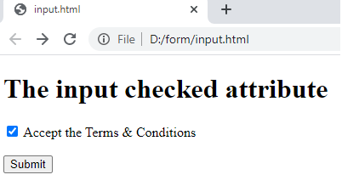

# HTML <input> maxlength Attribute

The maxlength attribute specifies the maximum number of characters allowed in the <input> element.

Ex:

<!DOCTYPE html>

<html>

<body>

<h1>The input maxlength attribute</h1>

<form action="result.html">

<label for="username">Username:</label>

<input type="text" id="username" name="username" maxlength="10"><br><br>

<input type="submit" value="Submit">

</form>

<p> Assume my username is anilkumar123 </p>

<p> As the username has maxlength of 10. I can able to enter upto anilkumar1 .</p>

<p> maxlength restricts the user by entering characters upto to maxlength </p>

</body>

</html>

Output:

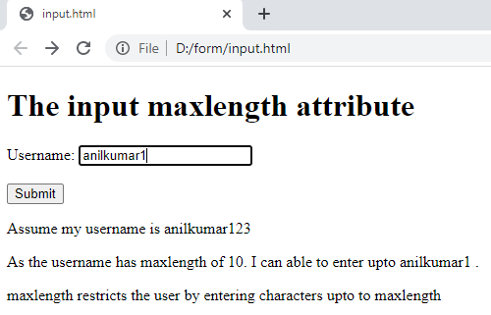

# HTML size Attribute

The input size attribute specifies the visible width, in characters, of an input field.

The default value for size is 20.

**Note:** The size attribute works with the following input types: text, search, tel, url, email, and password.

Ex:

<!DOCTYPE html>

<html>

<body>

<h1>The input size attribute</h1>

<form action="result.html">

<label for="fname">First name:</label>

<input type="text" id="fname" name="fname" size="50"><br><br>

<label for="pin">PIN:</label>

<input type="text" id="pin" name="pin" maxlength="4" size="4"><br><br>

<input type="submit" value="Submit">

</form>

</body>

</html>

Output:

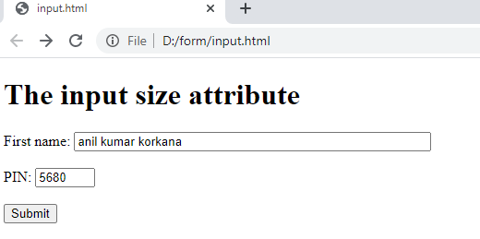

You can observe, in the first name field we can able to enter upto 50 characters.

And in the pin we can able to enter upto 4 characters.

You can also observe the length of the text box.

# HTML <input> min & max Attribute

The min attribute specifies the minimum value for an <input> element.

The max attribute specifies the maximum value for an <input> element.

**Tip:** Use the min attribute together with the [max](https://www.w3schools.com/tags/att_input_max.asp) attribute to create a range of legal values.

**Tip:** Use the max attribute together with the [min](https://www.w3schools.com/tags/att_input_min.asp) attribute to create a range of legal values.

**Note:** The max and min attributes works with the following input types: number, range, date, datetime-local, month, time and week.

Ex:

<!DOCTYPE html>

<html>

<body>

<h1>The input max and min attributes</h1>

<form action="result.html">

<label for="datemax">Enter a date before 1980-01-01:</label>

<input type="date" id="datemax" name="datemax" max="1979-12-31"><br><br>

<label for="datemin">Enter a date after 2000-01-01:</label>

<input type="date" id="datemin" name="datemin" min="2000-01-02"><br><br>

<label for="quantity">Quantity (between 1 and 5):</label>

<input type="number" id="quantity" name="quantity" min="1" max="5"><br><br>

<input type="submit">

</form>

</body>

</html>

Output:

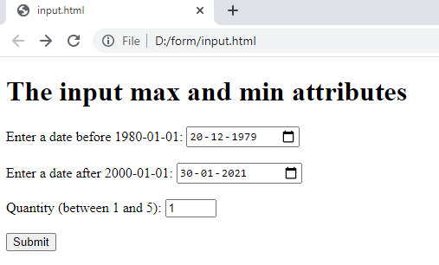

# HTML <input> readonly Attribute

The readonly attribute is a boolean attribute.

When present, it specifies that an input field is read-only.

A read-only input field cannot be modified (however, a user can tab to it, highlight it, and copy the text from it).

The readonly attribute can be set to keep a user from changing the value until some other conditions have been met (like selecting a checkbox, etc.). Then, a JavaScript can remove the readonly value, and make the input field editable.

**Note:** A form will still submit an input field that is readonly, but will not submit an input field that is disabled!

Ex:

<!DOCTYPE html>

<html>

<body>

<h1>The input readonly attribute</h1>

<form action="result.html">

<table>

<tr>

<td><label for="email">Email Id:</label> </td>

<td> <input type="email" id="email" name="email" value="anilkumar.w3c@gmail.com" readonly> </td>

</tr>

<tr>

<td> <label for="msg">Enter Your Message:</label> </td>

<td><textarea id="msg" name="msg" rows="4" cols="50">

submit your queries to this mail id.

</textarea> </td>

<tr>

<td> </td>

<td> <input type="submit" value="Submit"> </td>

</tr>

</table>

</form>

</body>

</html>

Output:

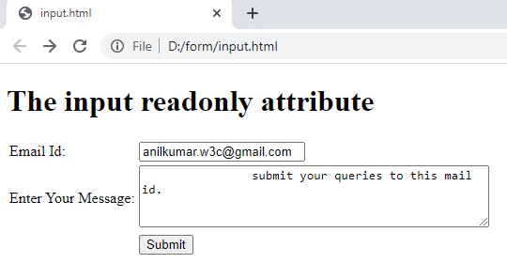

In this example you can observe , you can’t able to change the value of email id field manually.

# HTML <input> disabled Attribute

The disabled attribute is a boolean attribute.

When present, it specifies that the <input> element should be disabled.

A disabled input element is unusable and un-clickable.

The disabled attribute can be set to keep a user from using the <input> element until some other condition has been met (like selecting a checkbox, etc.). Then, a JavaScript could remove the disabled value, and make the <input> element usable.

**Tip:** Disabled <input> elements in a form will not be submitted!

Ex 1:

<!DOCTYPE html>

<html>

<body>

<h1>The input disabled attribute</h1>

<form action="result.html">

<label for="fname">First name:</label>

<input type="text" id="fname" name="fname"><br><br>

<label for="lname">Last name:</label>

<input type="text" id="lname" name="lname" disabled><br><br>

<input type="submit" value="Submit">

</form>

</body>

</html>

Output:

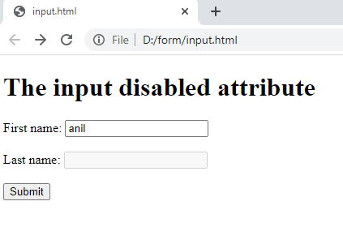

In this example , you can observe you cannot able to give value for last name field, as the last name field was disabled.

Ex 2. Making submit button disabled.

<!DOCTYPE html>

<html>

<body>

<h1>The input disabled attribute</h1>

<form action="result.html">

<label for="fname">First name:</label>

<input type="text" id="fname" name="fname"><br><br>

<label for="lname">Last name:</label>

<input type="text" id="lname" name="lname"><br><br>

<input type="submit" value="Submit" disabled>

</form>

</body>

</html>

Output:

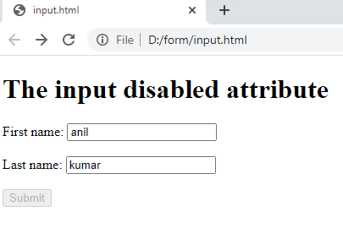

You can observe the form cannot be submitted as the submit button was disabled.

Ex 3 .

A form will still submit an input field that is readonly, but will not submit an input field that is disabled!

<!DOCTYPE html>

<html>

<body>

<h1>readonly and disabled attribute</h1>

<form action="result.html">

<label for="fname">First name:</label>

<input type="text" id="fname" name="fname" value="anil" readonly><br><br>

<label for="lname">Last name:</label>

<input type="text" id="lname" name="lname" value="kumar" disabled><br><br>

<label for="email">Email:</label>

<input type="email" id="email" name="email">

<br><br>

<input type="submit" value="Submit" >

</form>

</body>

</html>

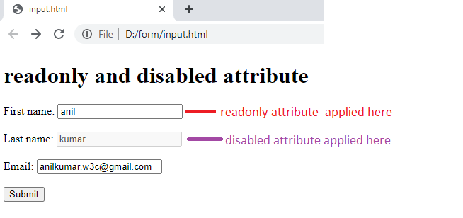

After clicking on submit button , the output will be

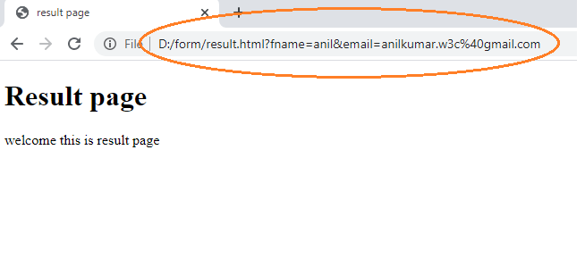

In the result page, you can observe you received only fname and email values.

As fname is readonly, where as you didn’t receive lname value, as lname having disabled attribute.

The value Attribute

The input value attribute specifies an initial value for an input field:

Ex:

<!DOCTYPE html>

<html>

<body>

<h1>The input value attribute</h1>

<p>The value attribute specifies an initial value for an input field:</p>

<form action="result.html">

<label for="fname">First name:</label><br>

<input type="text" id="fname" name="fname" value="Anil"><br>

<label for="lname">Last name:</label><br>

<input type="text" id="lname" name="lname" value="Kumar"><br><br>

<input type="submit" value="Submit">

</form>

</body>

</html>

Output:

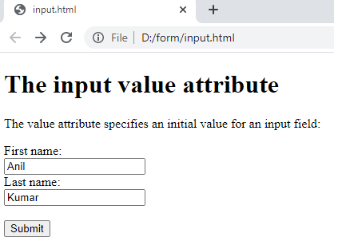

The pattern Attribute

The input pattern attribute specifies a regular expression that the input field's value is checked against, when the form is submitted.

The pattern attribute works with the following input types: text, date, search, url, tel, email, and password.

Ex: using pattern attribute for an Indian mobile number , we know that Indian mobile consists of 10 digits with starting of either [ 9 / 8 / 7 /6 ] followed by 9 digits.

So the equivalent pattern for the Indian mobile no is. ^[6-9]\d{9}$

The pattern is also called as regex ( regular expression )

<!DOCTYPE html>

<html>

<body>

<h1>The input pattern attribute</h1>

<p>The pattern attribute specifies a regular expression that the input element's value is checked against.</p>

<form action="result.html" method="GET">

<label for="phno">Phone no:</label>

<input type="text" id="phno" name="phno" pattern="^[6-9]\d{9}$" title="Enter your mobile no" size="10" maxlength="10"><br><br>

<input type="submit" value="Submit">

</form>

</body>

</html>

Output 1:

Trying to enter invalid Indian mobile no.

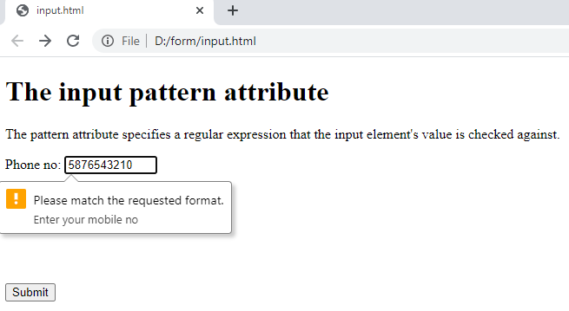

Output 2:

Now trying to enter valid mobile no.

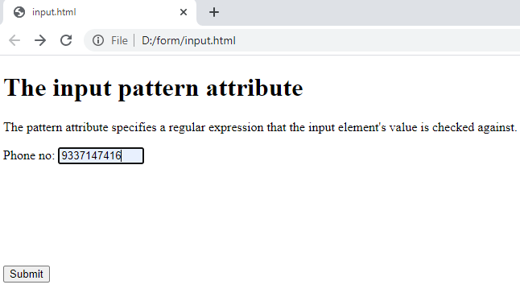

After clicking on submit the result will be

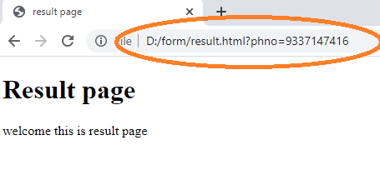

You can observe the phone no in the result page.

The placeholder Attribute

The input placeholder attribute specifies short a hint that describes the expected value of an input field (a sample value or a short description of the expected format).

The short hint is displayed in the input field before the user enters a value.

The placeholder attribute works with the following input types: text, search, url, tel, email, and password.

Ex:

<!DOCTYPE html>

<html>

<body>

<h1>The input placeholder attribute</h1>

<p>The placeholder attribute specifies a short hint that describes the expected value of an input field.</p>

<form action="result.html">

<label for="uname">User Name:</label>

<input type="text" id="uname" name="uname" placeholder="Enter User Name"><br><br>

<input type="submit" value="Submit">

</form>

</body>

</html>

Output:

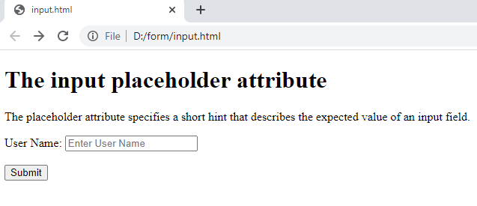

The autofocus Attribute

The input autofocus attribute specifies that an input field should automatically get focus when the page loads.

Ex:

<!DOCTYPE html>

<html>

<body>

<h1>The input autofocus attribute</h1>

<p>The autofocus attribute specifies that the input field should automatically get focus when the page loads.</p>

<form action="result.html">

<label for="fname">First name:</label><br>

<input type="text" id="fname" name="fname" autofocus><br>

<label for="lname">Last name:</label><br>

<input type="text" id="lname" name="lname"><br><br>

<input type="submit" value="Submit">

</form>

</body>

</html>

Output:

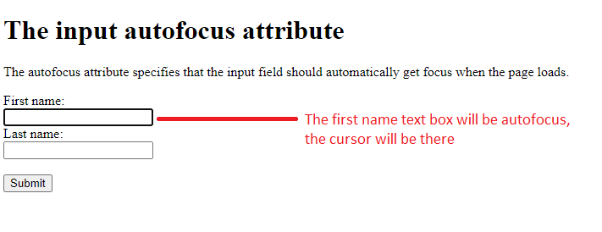

# HTML <button> Tag

The <button> tag defines a clickable button.

Inside a <button> element you can put text (and tags like <i>, <strong>, <br>, <img>, etc.). This is not possible with a button created with the [<input>](https://www.w3schools.com/tags/tag_input.asp) element!

**Tip:** Always specify the type attribute for a <button> element, to tell browsers what type of button it is.

Ex 1:

<!DOCTYPE html>

<html>

<body>

<form action="result.html">

<label for="fname">First name:</label><br>

<input type="text" id="fname" name="fname"><br>

<label for="lname">Last name:</label><br>

<input type="text" id="lname" name="lname"><br><br>

<button type="submit"> <img src="images/submit.png" width="100" height="100"> </button>

</form>

</body>

</html>

Output:

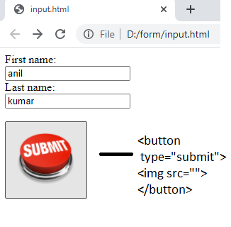

After clicking on the button, the output will be

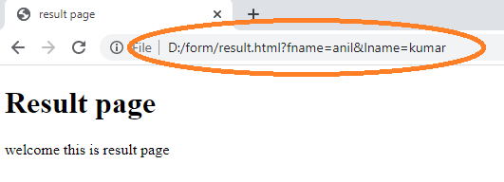

Ex2:

<!DOCTYPE html>

<html>

<body>

<h1>The button Element</h1>

<button type="button" onclick="alert('Hello world!')">Click Me!</button>

</body>

</html>

Output:

Click on the button, you will get alert message.

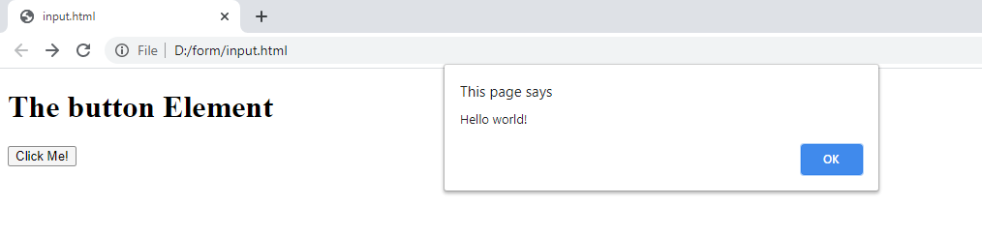

The <select> Element

The <select> element defines a drop-down list:

Ex:

<!DOCTYPE html>

<html>

<body>

<h2>The select Element</h2>

<p>The select element defines a drop-down list:</p>

<form action="result.html">

<label for="course">Choose your course:</label>

<select id="course" name="course">

<option> -- select your course -- </option>

<option value="bsc3">BSC 3rd Year</option>

<option value="bca3">BCA 3rd Year</option>

<option value="bsc2">BSC 2rd Year</option>

<option value="bca2">BCA 2rd Year</option>

<option value="bsc1">BSC 1rd Year</option>

<option value="bca1">BCA 1rd Year</option>

</select>

<br><br><br>

<input type="submit">

</form>

</body>

</html>

Output:

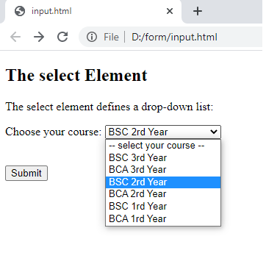

Selected BSC 2 nd year . and clicked on submit button, the result page will be

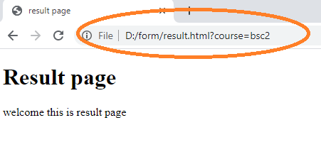

### Allow Multiple Selections:

Use the multiple attribute to allow the user to select more than one value:

Ex:

<!DOCTYPE html>

<html>

<body>

<h2>The select Element</h2>

<p>The select element defines a drop-down list:</p>

<form action="result.html">

<label for="course">Choose your course:</label>

<select id="course" name="course" size="4" multiple>

<option value="html">HTML</option>

<option value="css">CSS</option>

<option value="bootstrap">BOOTSTRAP</option>

<option value="javascript">JAVASCRIPT</option>

<option value="php">PHP</option>

<option value="java">JAVA</option>

</select>

<br><br><br>

<input type="submit">

</form>

</body>

</html>

Output:

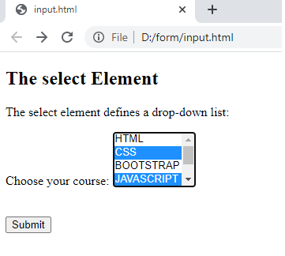

Selected css & javascript and click on submit, the result page will be

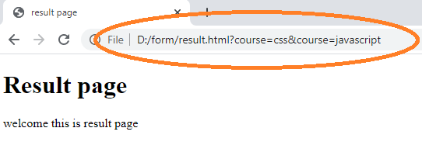

The <textarea> Element

The <textarea> element defines a multi-line input field (a text area):

Ex:

<!DOCTYPE html>

<html>

<body>

<h2>Textarea</h2>

<p>The textarea element defines a multi-line input field.</p>

<form action="result.html">

<textarea name="message" rows="10" cols="30"></textarea>

<br><br>

<input type="submit">

</form>

</body>

</html>

The rows attribute specifies the visible number of lines in a text area.

The cols attribute specifies the visible width of a text area.

Output:

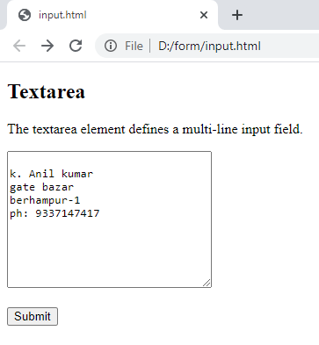

After entering value in textarea , click on submit button , the output will be

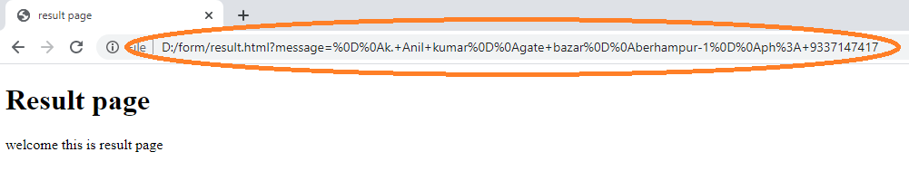

The <fieldset> and <legend> Elements

The <fieldset> element is used to group related data in a form.

The <legend> element defines a caption for the <fieldset> element.

Ex:

<!DOCTYPE html>

<html>

<head>

<style>

div{

width:30%;

height:400px;

}

</style>

</head>

<body>

<h2>Grouping Form Data with Fieldset</h2>

<p>The fieldset element is used to group related data in a form, and the legend element defines a caption for the fieldset element.</p>

<div>

<form action="/action_page.php">

<fieldset>

<legend>Login:</legend>

<label for="uname">User Name:</label><br>

<input type="text" id="uname" name="uname"><br>

<label for="pwd">Password:</label><br>

<input type="password" id="pwd" name="pwd"><br><br>

<input type="submit" value="Submit">

</fieldset>

</form>

</div>

</body>

</html>

Output:

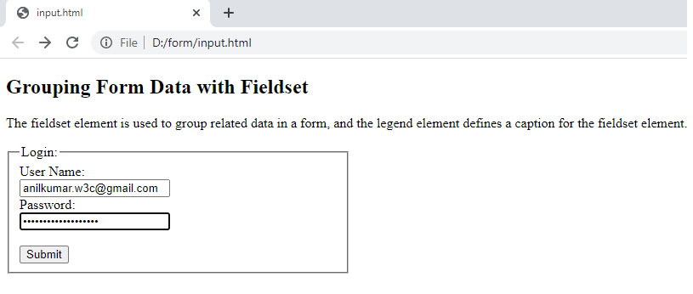

The form Attribute

The input form attribute specifies the form the <input> element belongs to.

The value of this attribute must be equal to the id attribute of the <form> element it belongs to.

Ex:

<!DOCTYPE html>

<html>

<body>

<h1>The input form attribute</h1>

<p>The form attribute specifies the form an input element belongs to.</p>

<form action="result.html" id="form1">

<label for="fname">First name:</label>

<input type="text" id="fname" name="fname"><br><br>

<input type="submit" value="Submit">

</form>

<p>The "Last name" field below is outside the form element, but still part of the form.</p>

<label for="lname">Last name:</label>

<input type="text" id="lname" name="lname" form="form1">

</body>

</html>

Output:

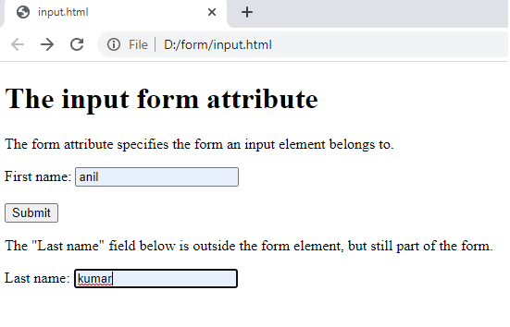

After entering values, now click on submit. The output of result page

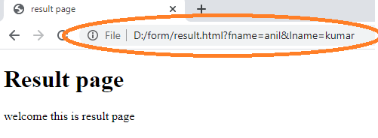

The formaction Attribute

The input formaction attribute specifies the URL of the file that will process the input when the form is submitted.

**Note:** This attribute overrides the action attribute of the <form> element.

Ex:

<!DOCTYPE html>

<html>

<body>

<h1>The input formaction attribute</h1>

<p>The formaction attribute specifies the URL of a file that will process the input when the form is submitted.</p>

<form action="result.html">

<label for="fname">First name:</label>

<input type="text" id="fname" name="fname"><br><br>

<label for="lname">Last name:</label>

<input type="text" id="lname" name="lname"><br><br>

<input type="submit" value="User Login">

&nbsp;&nbsp;&nbsp;&nbsp;&nbsp;&nbsp;

<input type="submit" formaction="adminresult.html" value="Admin Login">

</form>

</body>

</html>

Output 1 :

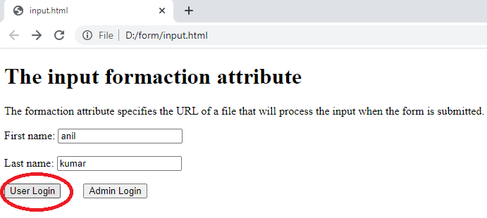

Entered the values of first name & last name, now click on User Login, it will take to the result.html page ( action attribute ).

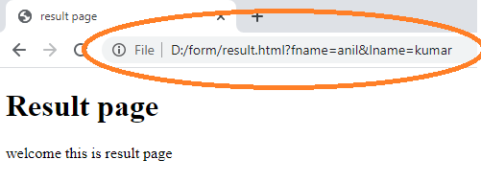

Output 2:

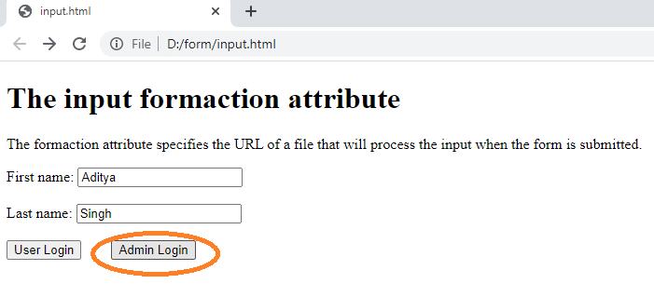

After entering first name and last name, if the user clicks on admin login, then the values will be taken to adminresult.html ( as formaction attribute overrides the action attribute ) , then the result will be..

